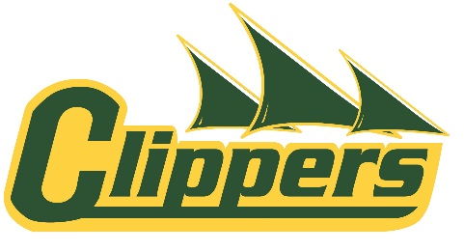

LCI Green and Gold Volleyball Tournament

Attention: Varsity Boys and Girls Volleyball Coaches

We would like to extend an invitation to the annual Green and Gold Volleyball Tournament – 2016 edition. The tournament will be running a similar format as last year since it was such a success. We’ll be hosting a two day tournament and each team will be guaranteed 6 matches (with an 8 team draw). The top 4 teams in each pool will advance to playoffs and the others will play a cross-over match. Prizes will be awarded for the top teams in the tournament.

The tournament will be open to competitive 3A and 4A boys and girls Varsity teams.
DATE: September 30th – October 1st, 2016
NEEDED: 12 Senior Boys Teams
12 Senior Girls Teams
ENTRY FEE: $350

Please fill out the registration form below and return to: chris.harris@lethsd.ab.ca

Cheques should be made payable to:
Lethbridge Collegiate Institute
1701 5th Avenue South
Lethbridge, Alberta
T1J 0W4
Payments may also be accepted online at https://lethbridge.schoolcashonline.com/

Thank you for considering our tournament.
Sincerely,
Chris Harris
Athletic Director

LCI Green and Gold Volleyball Tournament Registration Form
September 30 – October 1st, 2016

REGISTRATION FORM
School Name: ________________________________________

City: ____________________________________________

Phone #: ( ) _________________________________

Women’s Team Name: ____________________________
Coach/Contact Name: ____________________________
Email: _________________________________________
Cell Phone: ______________________________________

Men’s Team Name: _____________________________
Coach/Contact Name: ___________________________
Email: _______________________________________
Cell Phone: ____________________________________

Please email registration to: chris.harris@lethsd.ab.ca

