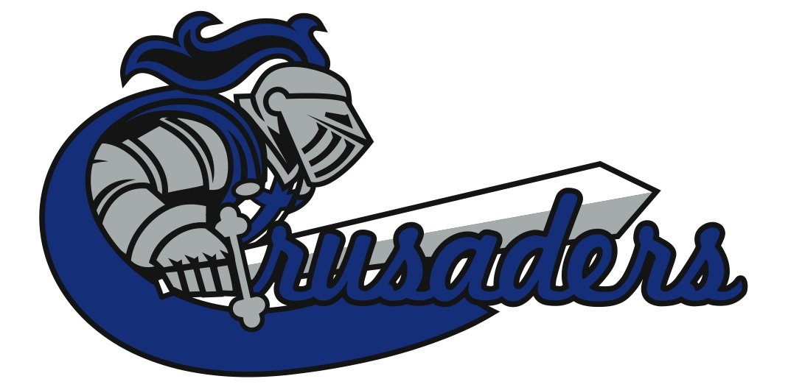

The Lakeland Cup 2018

Cold Lake High School and Assumption Junior Senior High School are hosting at JV Tournament Feb 9-10, 2017

It will be Oregon draw and we are seeking 8 Girls and Boys Team

The Entry fee is $350

Heart and Hustle awards/ half-time games and more

Any questions please contact Kelly Eagles
kelly.eagles@nlsd.ab.ca

Entry fees will secure your registration spot

