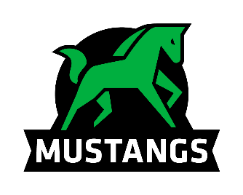
Onoway Mustangs
Sr Boys Volleyball Tournament

We would like to invite you to our Sr Boys Volleyball tournament on September 28th and 29th , 2018. We will be running an 8 team draw with round robin and playoffs. All teams are guaranteed 5 games. Registration fees are $325 per team. Payable by cheque to Onoway Jr Sr High School. There will be medals for 1st and 2nd place. If you are interested in attending the best way to register is to email the completed registration form to corey.lougheed@ngps.ca. If you have any questions you can reach me via email or by phone at 780-967-2271.

Corey Lougheed – Sr Girls Coach

Registration Form
School Name: __________________________________
Contact Name: ________________________________
Contact Phone #: _______________________________
Contact Email: __________________________________
Team Name: ___________________________________

