6TH ANNUAL BLUE DEVIL CLASSIC
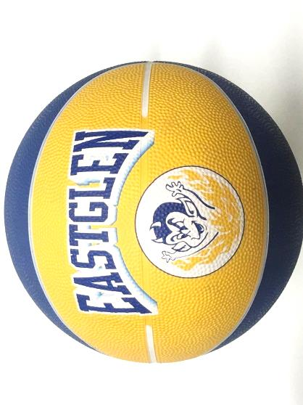
BASKETBALL TOURNAMENT
February 7-9, 2019

- 10 Team Draw 3 Game Guarantee (some will play 4)
- Great Swag
- 2- Ball Competition
- Player of the game awards
- Coaches Room – great food
- Concession available all tournament
- $400 Entry fee per team
- Carded ABOA Officials for all games
- Tournament MVP and SKILLZ winners will receive gear
- Awards for Champions, 2nd and Consolation winners

* RSVP our Athletic Director to confirm your spot! dan.gosse@epsb.ca

