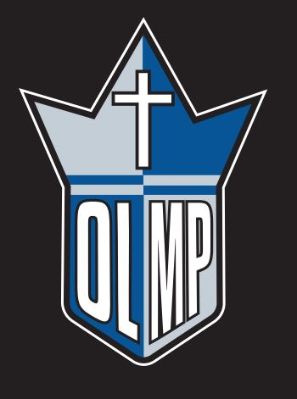
4th Annual OLMP Winter Warm-Up
When: December 14-15th, 2018
Draw Format: 8-Team Oregon Draw
Fee: $325/ team
Teams: 1A, 2A Sr. Girls
Prizes:
- Medals for 1st
- Plaques for 2nd, 3rd and Consolation
- T-shirts for Most Defensive Player from each team.
Required: Team roster and logo for tournament booklets (by December 7th)
Please email jaymier@eics.ab.ca for registration into the tournament.

