ASAA High School Badminton Provincials 2016 Map

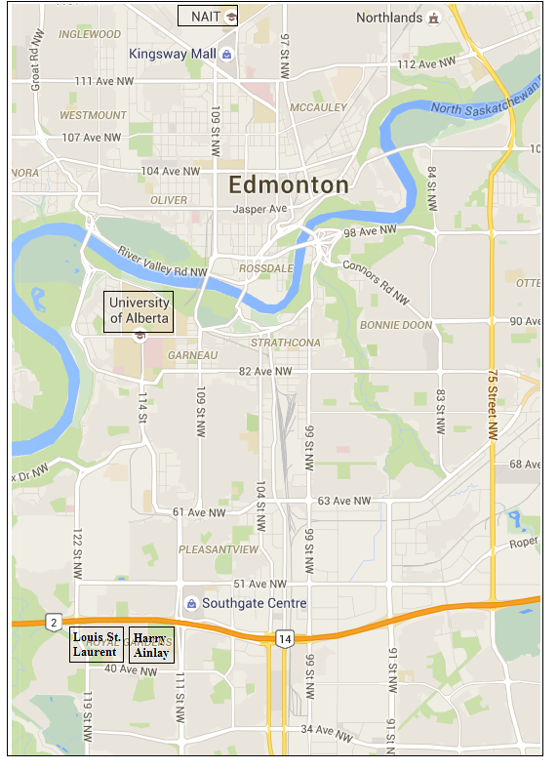
University of Alberta (U of A) - Main Gym inside Van Vliet Centre

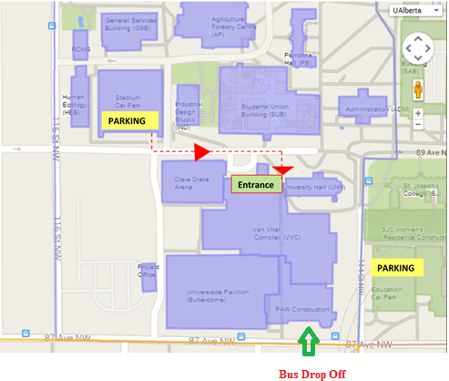

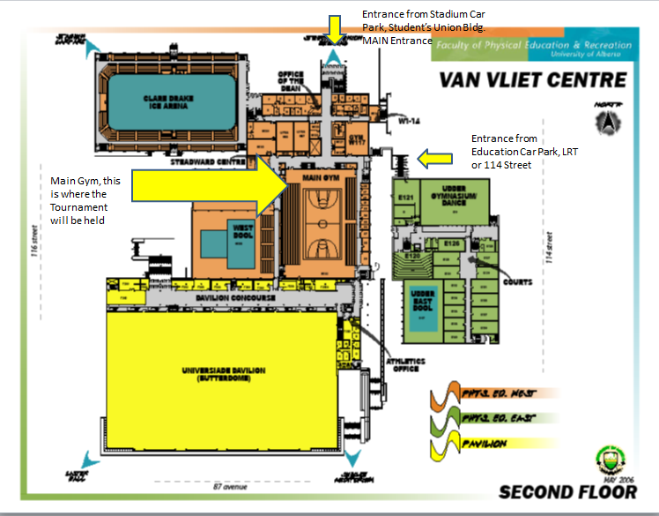
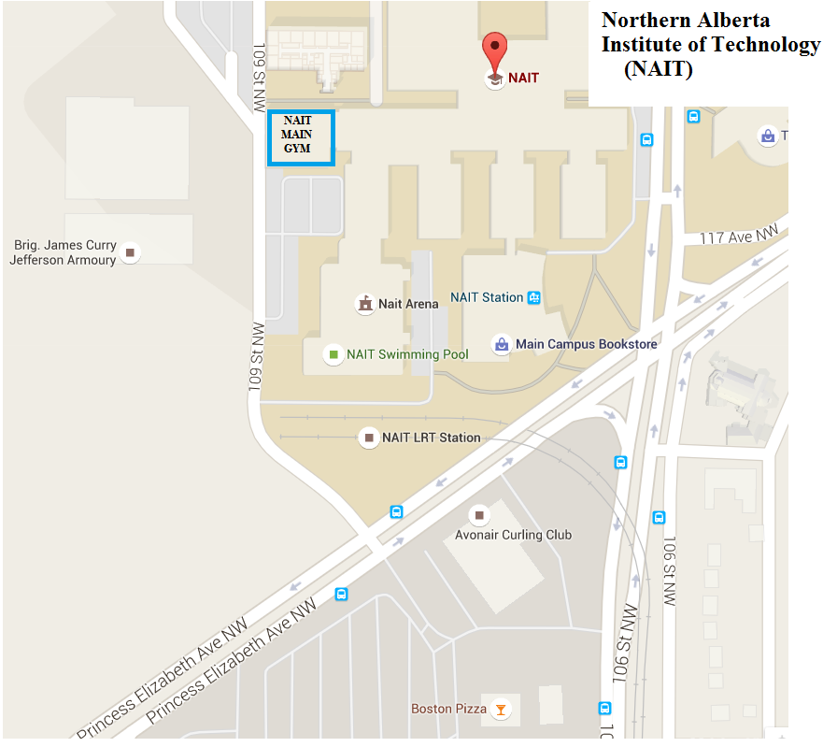
NAIT Main gym

Harry Ainlay and Louis St. Laurent Schools (gym is easily accessible through NE lot at HA and E entrance at Louis St. Laurent)
