Venues/Event

Friday (8:30 AM -1:00 PM) Breakfast and Opening Ceremonies

- Harry Ainlay High School (Free Parking)

Friday (1:30-6:30 PM) & Saturday (8:30 AM-12:00 PM)

Round Robin Matches (Friday, Beginning at 1:30 pm)
Quarter-Finals and Semi-Finals (Saturday Morning, Beginning at 8:30 am)
Venue | Address | Event | Court Number
U of A | Parking at 116 St and 87 Ave NW  ($14) | Junior Girls Singles | 1, 2
 |  | Intermediate Girls Singles | 3, 4
 |  | Senior Girls Singles | 5, 6
 |  | Junior Mixed Doubles | 7, 8
 |  | Intermediate Mixed Doubles | 9, 10
NAIT | 11762 106 St NW | Junior Boys Singles | 13, 14
 |  | Intermediate Boys Singles | 15, 16
 |  | Senior Boys Singles | 17, 18
Harry Ainlay | 4350 111 St NW | Junior Girls Doubles | 19, 20
 |  | Intermediate Girls Doubles | 21, 22
 |  | Senior Girls Doubles | 23, 24
 |  | Senior Mixed Doubles | 25, 26
Louis St. Laurent | 11230 43 Ave NW | Intermediate Boys Doubles | 27, 28
 |  | Senior Boys Doubles | 29, 30
 |  | Junior Boys Doubles | 31, 32

Saturday 12:30-4:30 PM
All Final Games (Saturday, Beginning at 12:00 pm)
(A-Side and B-Side)
Venue | Address | Event | Court Number
U of A | Parking at 116 St and 87 Ave NW  ($5) | Boys Singles | 1, 2
 |  | Girls Singles | 3, 4
 |  | Boys Doubles | 5, 6
 |  | Girls Doubles | 7, 8
 |  | Mixed Doubles | 9, 10

ASAA High School Badminton Provincials 2016 Venue and Court Numbers
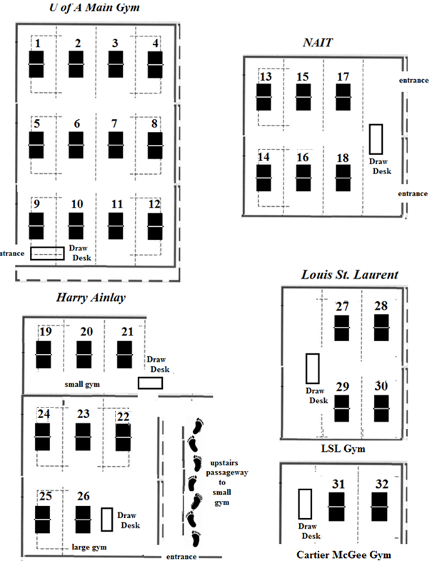

Pools and Game Schedule for Round Robin (Friday: All Events)

Round Robin Teams by Pool
Pool A |  |  | Pool B
Team | Zone |  | Team | Zone
1 | Edmonton 1 |  | 2 | Edmonton 2
5 | Central 2 |  | 6 | Central 1
9 | Northeast 1 |  | 10 | Northeast 2
13 | Northcentral 2 |  | 14 | Northcentral 1
Pool C |  |  | Pool D
Team | Zone |  | Team | Zone
3 | Calgary 1 |  | 4 | Calgary 2
7 | Southcentral 2 |  | 8 | Southcentral 1
11 | Northwest 1 |  | 12 | Northwest 2
15 | South 2 |  | 16 | South 1

Game Schedule for Round Robin
Pool | Time
 | 2:00 | 2:40 | 3:20 | 4:00 | 4:40 | 5:20
A | 1 vs 5 | 9 vs 13 | 1 vs 9 | 5 vs 13 | 1 vs 13 | 5 vs 9
B | 2 vs 6 | 10 vs 14 | 2 vs 10 | 6 vs 14 | 2 vs 14 | 6 vs 10
Pool | Time
 | 2:20 | 3:00 | 3:40 | 4:20 | 5:00 | 5:40
C | 3 vs 7 | 11 vs 15 | 3 vs 11 | 7 vs 15 | 3 vs 15 | 7 vs 11
D | 4 vs 8 | 12 vs 16 | 4 vs 12 | 8 vs 16 | 4 vs 16 | 8 vs 12

