Basketball Skills Assessment Tests (BSAT)

Dribbling
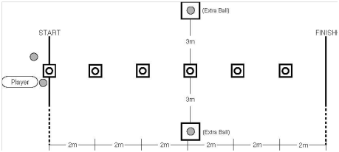

SET-UP
An area of the basketball court (preferably along a sideline or down the center line)
6 cones
Floor tape
4 basketballs: One that the athlete is provided initially, two others that are for back-up in case the basketball bounces away, and one more to continue the test.

TEST
Time: 60 seconds for one trial.
A player is instructed to dribble the ball while passing alternately to the right and to the left of six obstacles placed in a line, 2 meters (6 feet 6 3/4 inches) apart, on a 12-meter course. The player may start to the right or to the left of the first obstacle but must pass each obstacle alternately thereafter. When the last obstacle is passed and the finish line reached, the player puts the ball down, sprints back to the start for the next ball, and repeats the slalom. The player continues until 60 seconds have elapsed. If a player loses control of the ball, the clock continues to run. The player recovers the ball or picks up the nearest back-up ball and may re-enter at any point along the course.

SCORING
One point is awarded each time a cone is passed. (For example, if the player successfully dribbles the ball from the starting line, weaves in and out through the entire obstacle course one time, and places the ball down at the finish line, a score of five has been achieved. The player must use legal dribbles and must have control of the ball during a midpoint-to-next-midpoint space in order to get credit for that cone successfully passed). The player’s score is how many cones (midpoints) he/she successfully passes in 60 seconds.

STAGING
Volunteers administer the test and are not to interfere with any player who is performing the test. Volunteer A will instruct the group doing this particular test while Volunteer B demonstrates the actual test. Volunteer A will give a basketball to the player who will take the test, ask him/her if ready, will then say, “Ready”, “Go” and will count how many cones the player passes in 60 seconds. Volunteers B and C, who are standing behind the extra balls, will retrieve and replace the basketball whenever it goes out of play. Volunteer D will time and record the athlete’s score. Each volunteer is to administer the test and manage the area only.

Perimeter Shooting

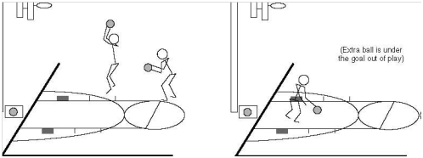

SET-UP
A goal
Official NGB free throw lane
Floor tape
2 basketballs: One that the athlete is provided initially, another that is for back-up in case the basketball bounces away.

TEST
Time: one trial of one minute.
A player stands at the juncture of the free-throw line and lane, either to the left or right. The player dribbles toward the goal and attempts a field goal of his/her choice outside the 2.75 meter (9 feet) arc. This attempt must be taken anywhere outside the 2.75 meter arc marked off by a dotted line. [This arc intersects with the free-throw restraining circle]. The player then rebounds the basketball (made or missed shot) and dribbles anywhere outside the arc before attempting another field goal. The player shall make as many field goals as described above in one one-minute trial.

SCORING
Two points are awarded for each field goal made within the one-minute trial.

STAGING
Volunteers administer the test and are not to interfere with any player who is performing the test. Volunteer A will instruct the group doing this particular test while Volunteer B demonstrates the actual test. Volunteer A will give a basketball to the player who will take the test, ask him/her if ready, will then say, “Ready, Go,” and will count how many field goals the player makes in one minute. Volunteer B, who is standing behind the extra ball, will retrieve and replace the basketball whenever it goes out of play. Volunteer C will time and record the athlete’s score. Each volunteer is to administer the test and manage the area only.

