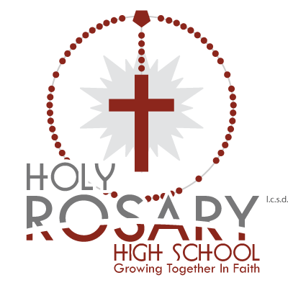
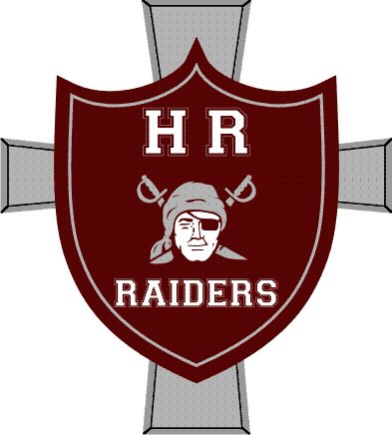
Lloydminster Holy Rosary

Sr. Boys and Girls Raiders Present:

HRIT 2017

Coaches,

We are hosting the senior girls’ and senior boys’ Holy Rosary Invitational Tournament on January 27-28. We would like to extend an invitation to your boys’ and girls’ teams. We are hoping for stronger 3A and 4A teams, and will be inviting provincial caliber 1A and 2A teams.

We will use an Oregon draw with 3 games guaranteed for all teams. There will be tournament awards for 2nd, 3rd, and Consolation Champs, and T-shirts for the Champions.

The entry fee is $350.00, with cheques payable to LCSD.

For additional information contact Mike Kardas (AD) – Sr. Boys at mkardas@lcsd.ca or Josh Lyons – Sr. Girls at jlyons@lcsd.ca

Thanks for your interest, and if you have any questions or concerns, please do not hesitate to ask.

Mike Kardas
Sr. Boys Basketball Coach

Josh Lyons
Sr. Girls Basketball Coach

