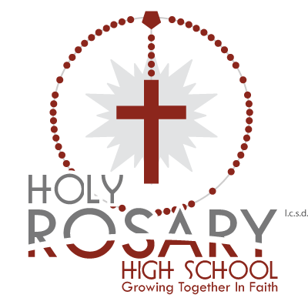
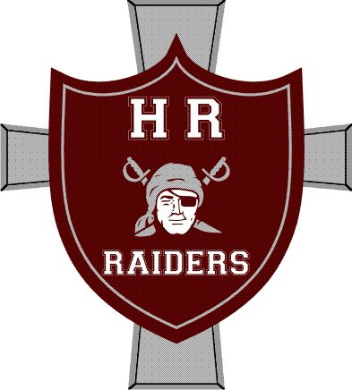
Lloydminster Holy Rosary

Sr. Boys and Girls Raiders Present:

HRIT 2018

Coaches,

We are hosting the senior girls’ and senior boys’ Holy Rosary Invitational Tournament on February 9th and 10th, 2018. We would like to extend an invitation to your boys’ and girls’ teams. In the past we have hosted stronger 3A and 4A teams, and will be inviting provincial caliber 1A and 2A teams, in hopes of a continually competitive tournament. Last year we had to turn teams away, so please confirm your registration as soon as possible.

We will use an Oregon draw with 3 games guaranteed for all teams. There will be tournament awards for 2nd, 3rd, and Consolation Champs, and T-shirts for the Champions, as well as Player of the Game awards for each team in each game.
There will be a Coaches/Refs Room set up adjacent to the gym at Holy Rosary; please make use of it – there will be plenty of food.

The entry fee is $350, with cheques payable to LRCSSD #89.

Two separate venues will be in use: St. Thomas Elementary and Holy Rosary High School – please be certain of which venue you will be playing.

For additional information contact:
Mike Kardas (AD) – Sr. Boys at mkardas@lcsd.ca
or
Josh Lyons – Sr. Girls at jlyons@lcsd.ca

Thanks for your interest, and if you have any questions or concerns, please do not hesitate to ask.

Josh Lyons
Sr. Girls Basketball Coach

