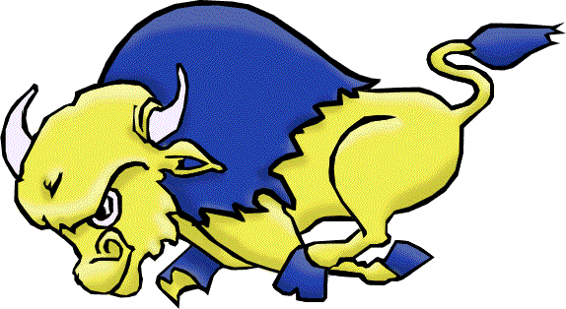
BROOKS COMPOSITE HIGH SCHOOL
JV BOYS BASKETBALL
2018 TOURNAMENT: Return of the Buffalos
Dates: Friday Feb 9th and 10th
Location: Brooks Composite High School
Format: 8 team Oregon draw. Games will consist of four 8 minute quarters, with a 5 minute half time, with the exception of the last 3 games (consolation final, bronze medal game, final), which will be 10 minute quarters and a 7 minute half time. All teams are guaranteed 3 games (1 Friday, 2 Saturday).
Tournament Fee: $300.00
Confirmations can be sent by:
Email to lindsay.spence@grasslands.ab.ca
Please include your team name and team colors if possible
Faxed to 403-362-0169
Please fill out the form below

YES, Our team would like to attend the BCHS boys tournament February 9-10th

Name of school: ___________________________
Name of team: ___________________________
Coach: ________________________
Contact phone number: ________________________
Coach email: ___________________________

Hope to see you and your team in December
Lindsay Spence
BCHS JV boys Basketball team

