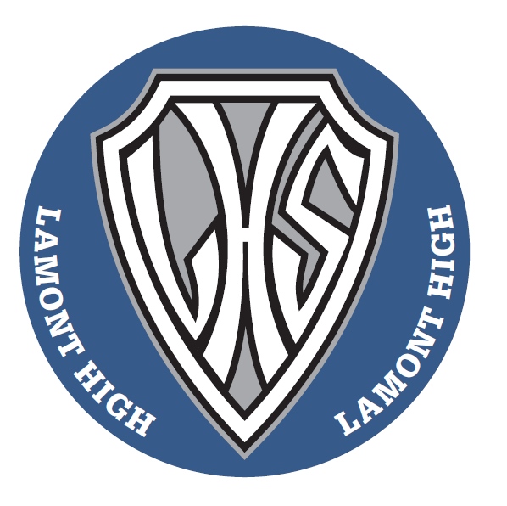

LAMONT LAKERS
HIGH SCHOOL CURLING OPEN BONSPIEL
JANUARY 26/27, 2018
COST: $70/TEAM
PLEASE EMAIL
Cory.Kokotailo@eips.ca to enter your teams

Open to all high school teams; boys, girls or mixed.

