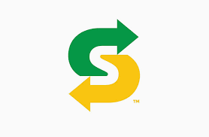
Saint’s Subway Select
Sr Girls basketball tourney
Dates: Friday, Dec 14th and Saturday, Dec 15th , 2018
Dear Coaches:
On behalf of the Sr. Girls’ Basketball team, we would like to invite you to the 2018 St. Mary’s Saints Subway Select Basketball Tournament. In hopes of a competitive tournament we will be inviting 2A and 3A teams as well as stronger 1A teams.
Require a deposit cheque of $100 (Payable to St. Mary’s Catholic School) for confirmation. Will not be refunded if you drop out and we cannot replace you.
Tournament Features:
- Tournament will consist of 12 Girls’ teams, with pool play to start
- ASAA modified FIBA rules
- Each team is guaranteed 3 games, with Player of the Game
- There will be a team 3 point contest Saturday afternoon
- All games are to be streamed online.
Entry Fee: $400.00
Registration:
Please enter your team by emailing the following information to
Mark Kobelsky at mark@eics.ab.ca
School Name: ____________________ Team Name: _____________________
Name of Coach: ___________________
Contact email: ____________________ Contact Number: __________________
Registration of teams will be confirmed by email prior to the end of June.

