Pearson InvitationAL Tournament
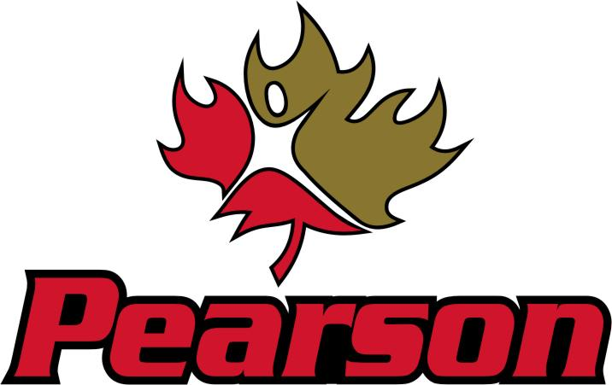

Junior & Senior Boys
Basketball Tournament

January 10-12, 2019

Lester B. Pearson High School
3020-52 Street NE
Calgary, AB, T1Y 5P4

JR and Sr Boys Basketball Tournament
Lester B. Pearson High School
January 10-12, 2019

Lester B Pearson High School in Calgary will be hosting our annual Junior and Senior Boys basketball tournament, to be held on Thursday-Saturday January 10-12th 2019. The Patriots extend an invitation to your team to participate in our competitive tournament.

- 6 boys’ teams at both the Junior & Senior level

- All teams are guaranteed three games

- Awards for Champion, Finalist, Third, Team MVP, Tournament MVP

- All of our matches will be running in our main gym

- The tournament entry fee is $400.00/team. Please forward cheques payable to Lester B. Pearson High School, or bring your cheque with you to give to Brian Scherban, Athletic Director.

- Please contact Sunny Minhas (paminhas@cbe.ab.ca) for any questions.

Looking forward to another great event!

Sunny Minhas
Sr Boys Basketball Coach
paminhas@cbe.ab.ca
403-280-6565 ext. 1185

