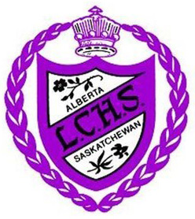
LCHS Junior Varsity Boys
Basketball Tournament

February 15th & 16th 2019

Hello Coaches,
On the weekend of February 15th and 16th the Junior Varsity boys’ basketball team will be hosting a tournament at Lloydminster Comprehensive High School. This will be a boys’ basketball tournament and are hoping for it being in an Oregon draw consisting of 8 teams and a guaranteed 3 games with player of the game awards and plaques for 1st, 2nd, 3rd and consolation winners.
The competition of teams expected from this tournament are Junior Varsity teams of any level, 1A - 2A level Senior teams from Alberta and 1A – 3A Senior teams from Saskatchewan.
Entry fee for the tournament is $150 and will be payable to LPSD. If you would like to ask questions or would like to confirm yourself for the tournament please e-mail kevin.sywenky@gmail.com or rebeca.wilson@lpsd.ca

Thanks,
Kevin Sywenky
LCHS JV Boys Basketball Head Coach
