Barrhead Composite High School

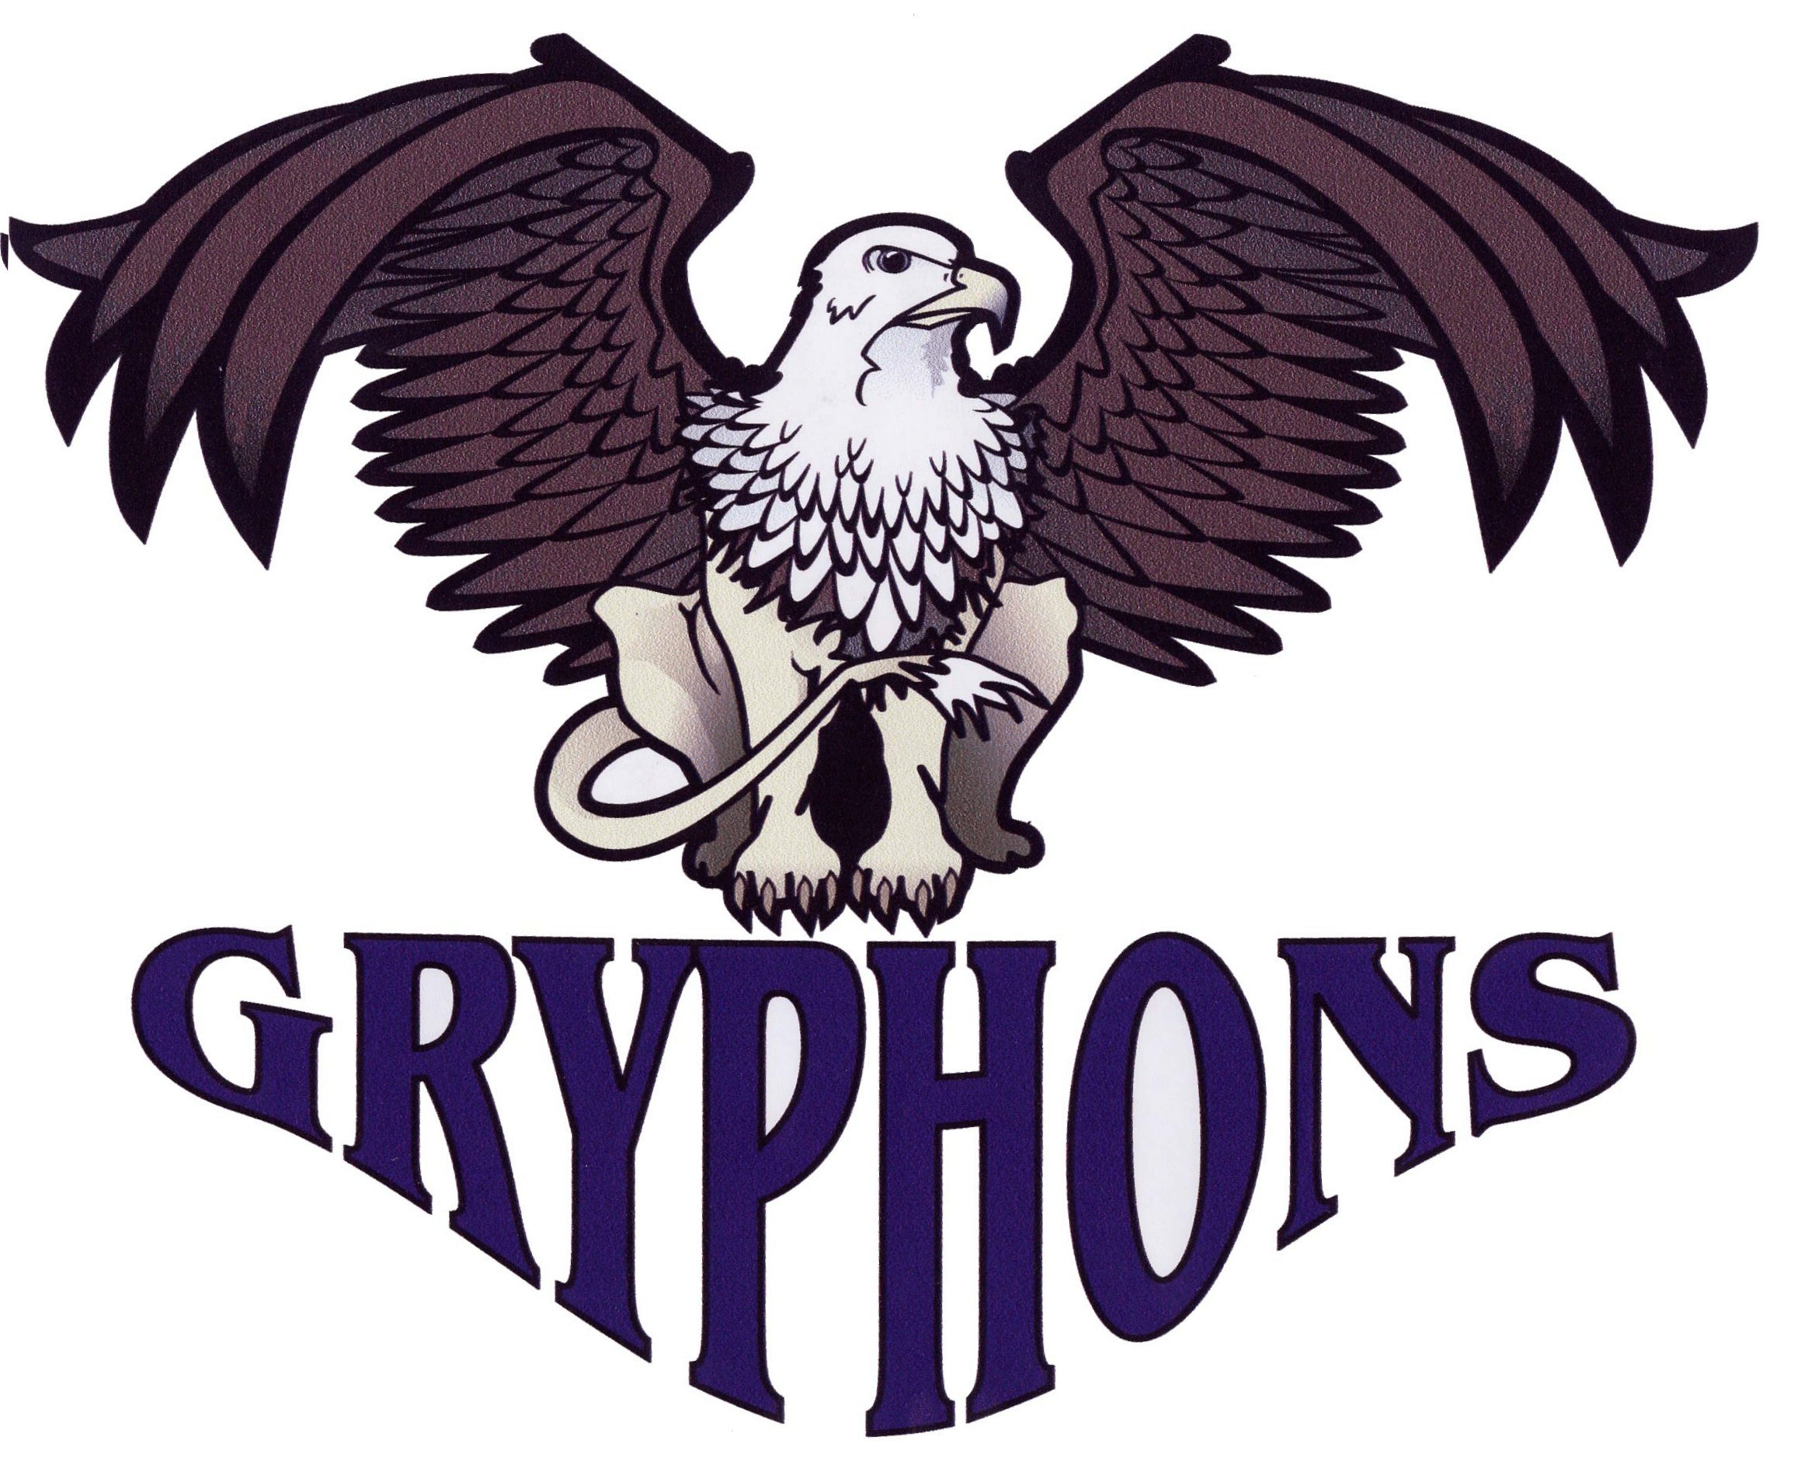
April 2, 2019

Dear Volleyball Coaches:

Senior Boys and Girls Volleyball Tournament

Barrhead Composite High School will be hosting the ~Gryphon Invitational~ Volleyball Tournament on Friday, October 4th and Saturday, October 5th^{th}, 2019

Format: In past years we have had 32 total teams (16 boys and 16 girls) and adopted a format allowing for a minimum of five matches. Number of entries will determine our tournament draw so teams who register both boys and girls teams will be given priority along with time of received entry into our tournament. We will keep a minimum of five matches, but if we have a lower number of entries, we may be able to increase the number of matches played due to the number of courts available to us.

Friday estimated schedule: 9:00am – 8:00pm
Saturday estimated schedule: 8:00 am – 7:00pm

Best 2 out of 3 matches, RALLY POINT games 1 and 2, to 25 points; game 3 to 15 points with no cap.

The entry fee for the tournament is $300.00 per team, payable to Barrhead Composite High School.

The deadline for entries will be the beginning of June.

Note if you register for this tournament and plan to stay in hotels, book prior to the Summer Break.
Barrhead Inn and Suites 1-877-674-7521 email: reservations@thebarrhead.com
Barrhead Neithbourhood Inn 1-800-216-7210

School Billet: We do offer the opportunity for schools to stay in the school to save costs.
Room charge $45.00 per room – non-refundable

Please send the attached entry form along with entry fee to confirm your spot in this tournament.

Yours truly,

Kyle Becker
Tournament Coordinator
Barrhead Composite High School
Kyle.becker@phrd.ab.ca
780-674-8522

Barrhead Composite High School

Gryphon Invitational Tournament

Senior Volleyball Tournament Entry Form:

School ________________________________ Male _____ Female _____

Team Name: ______________________Team Colors:___________________

Contact Name/Coach: ___________________________________________

Email: __________________________

Address: __________________________

__________________________

Postal Code: ______________ Phone Number: _______________________

Fax Number: _________________________

Billet Required: (Girls) ______ (Boys) ______

Make Cheques Payable to Barrhead Composite High School

Mail Cheque and Entry Form To: Fax
Kyle Becker Barrhead Composite High School Barrhead Composite High School 780-674-8543
5307 - 53 Avenue
Barrhead, AB T7N 1 P2 Email
Phone: 780-674-8522 kyle.becker@phrd.ab.ca

FOR BARRHEAD COMPOSITE HIGH SCHOOL ONLY:

Date Received: ________________________ Fees Received: ____________

