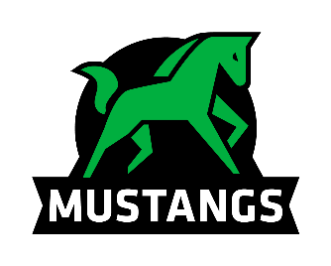
Onoway Mustangs
Sr Volleyball Tournament 2019

We would like to invite you to our Sr Girls and Boys Volleyball tournament on September 20th and 21st, 2019. We will be running an 8 team draw for boys and girls with round robin and playoffs. There will be medals for 1st and 2nd place.

If you are interested in attending the best way to register is to email the completed registration form to corey.lougheed@ngps.ca. Registration fees are $325 per team, payable by cheque to Onoway Jr Sr High School. If you have any questions you can reach me via email or by phone at 780-967-2271.

Corey Lougheed – Athletic Director/Sr Girls Coach

Registration Form
School Name: __________________________________
Contact Name: ________________________________
Contact Phone #: _______________________________
Contact Email: __________________________________
Team Name: ___________________________________

