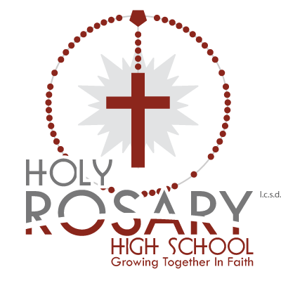
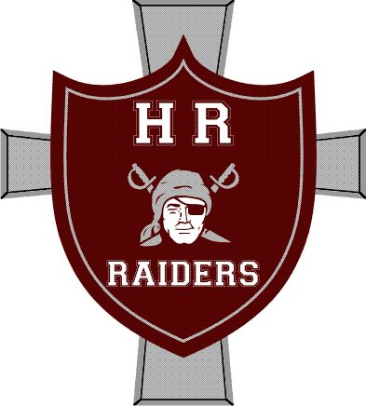
Lloydminster Holy Rosary

JV Boys Raiders Basketball

Tournament January 17-18, 2020

Hello Coaches,

We are hosting a JV Boys Basketball Tournament on January 17-18, 2020. We would like to extend an invitation to your boys’ team. All JV teams and 1A or 2A teams are welcome to attend. Last year we had to turn teams away, so please confirm your registration as soon as possible.

We will use an Oregon draw with 3 games guaranteed for all teams. There will be tournament awards for 2nd, 3rd, and Consolation Champs, and T-shirts for the Champions, as well as Player of the Game awards for each team in each game.
There will be a Coaches/Refs Room set up adjacent to the gym at Holy Rosary; please make use of it – there will be plenty of food.

The entry fee is $350, with cheques payable to LRCSSD #89.

Two separate venues will be in use: Holy Rosary High School and St. Thomas – please be certain of which venue you will be playing.

For additional information contact:
Mike Kardas (AD) – JV Boys Coach at mkardas@lcsd.ca (Phone 780-875-3600)

Thanks for your interest, and if you have any questions or concerns, please do not hesitate to ask.

Mike Kardas

JV Boys Basketball Coach

