August 26, 2019

Dear Coaches and Athletic Directors,

I am Jason Porteous, the senior boys basketball coach at JT Foster for this school year. On February 7th and 8th, we are hosting our 6th Annual Tournament and are looking for some great teams to join us!

The tournament fee will be $375 per team. Some of the highlights of our tournament:

Game MVP T-shirts for each game played.
Tournament Champion T-Shirts
Autograph ball trophies for 1st, 2nd, 3rd, and Consolation

A ton of fun for everyone! As always, all tournament games will be played next door at AB Daley School.

I look forward to hearing from you! Thank you for your consideration of our request.

Sincerely yours,
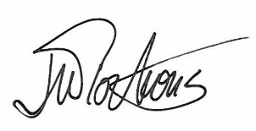
Jason Porteous

