Bashaw Volleyball Tournament 2020

Nov. 6/7, 2020
WELCOME
Bashaw would like to extend a welcome to all teams and participants. We hope you will find this year’s tournament both challenging and rewarding. We are looking at running an 8 team tournament this year.
ENTRY FEE
$275 per team. Please make cheques payable to: Bashaw School
Please pay by cheque prior to the tournament to confirm your spot.
TOURNAMENT FORMAT
Teams are in 2 pools. The top 2 teams in each pool will advance to the playoff round.
With a full tournament all teams are guaranteed 3 matches. The round robin matches are two sets with no cap. Any ties after round robin play will be broken using the ASAA tie breaking procedures.
- Sets won / lost between tied teams
- Points, for / against between tied teams.
- Points for / against in all matches.
Playoffs will be best two of three with the first two being to 25 with no cap and the third set being to 15 with no cap.
SCHEDULING
Due to time constraints, warm ups after the first matches of each day will be reduced in time unless we are running ahead of time. Should this occur you may have 5-5-5. Have your teams ready to go and be prepared to start early if by chance that should occur.
Access to all gyms will be no earlier than 30 minutes prior to the first match of each day.
MINOR OFFICIALS
Teams are asked to supply a linesman for each match.
TEAM SUPERVISION
Coaches are reminded to supervise their teams at all times. Volleyballs are for on court use only. Volleyballs are not to be played with in common areas, hall ways, etc.
PRIZES
A plaque and medals will be awarded to the tournament champion, and medals to the 2nd and 3rd place teams.
CONCESSION
We will have a concession open for the entire duration of the tournament (Breakfast, Lunch, and Supper). Coaches will receive 2 free meals.

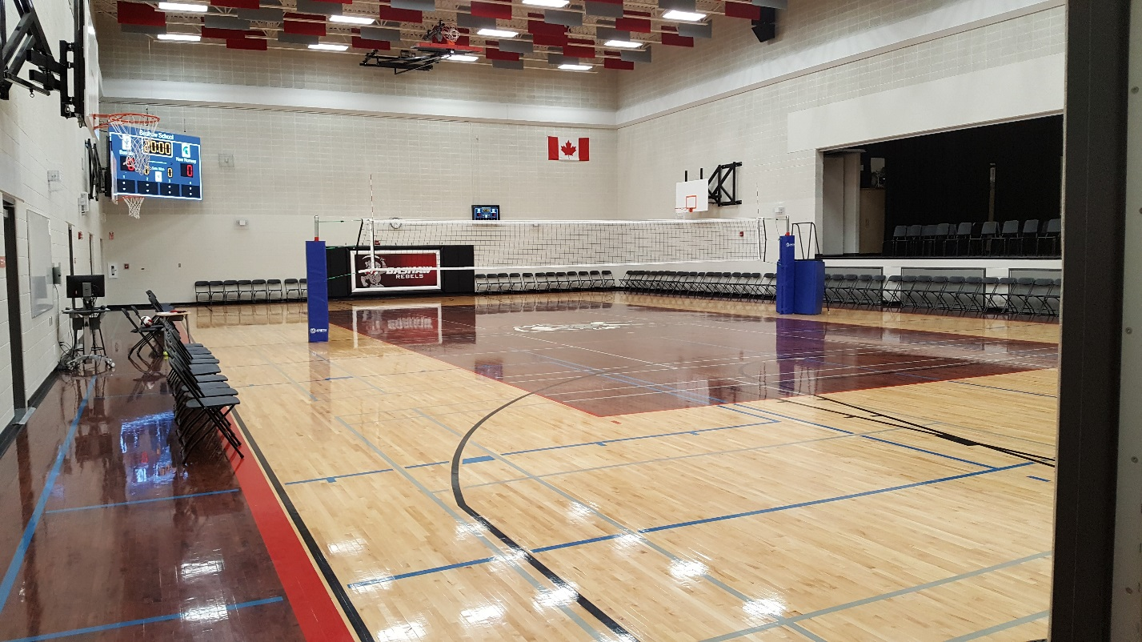

If you have any questions, please don’t hesitate to ask.
Jesse Vikse: Bashaw Sr. Boys Volleyball Coach jvikse@brsd.ab.ca

