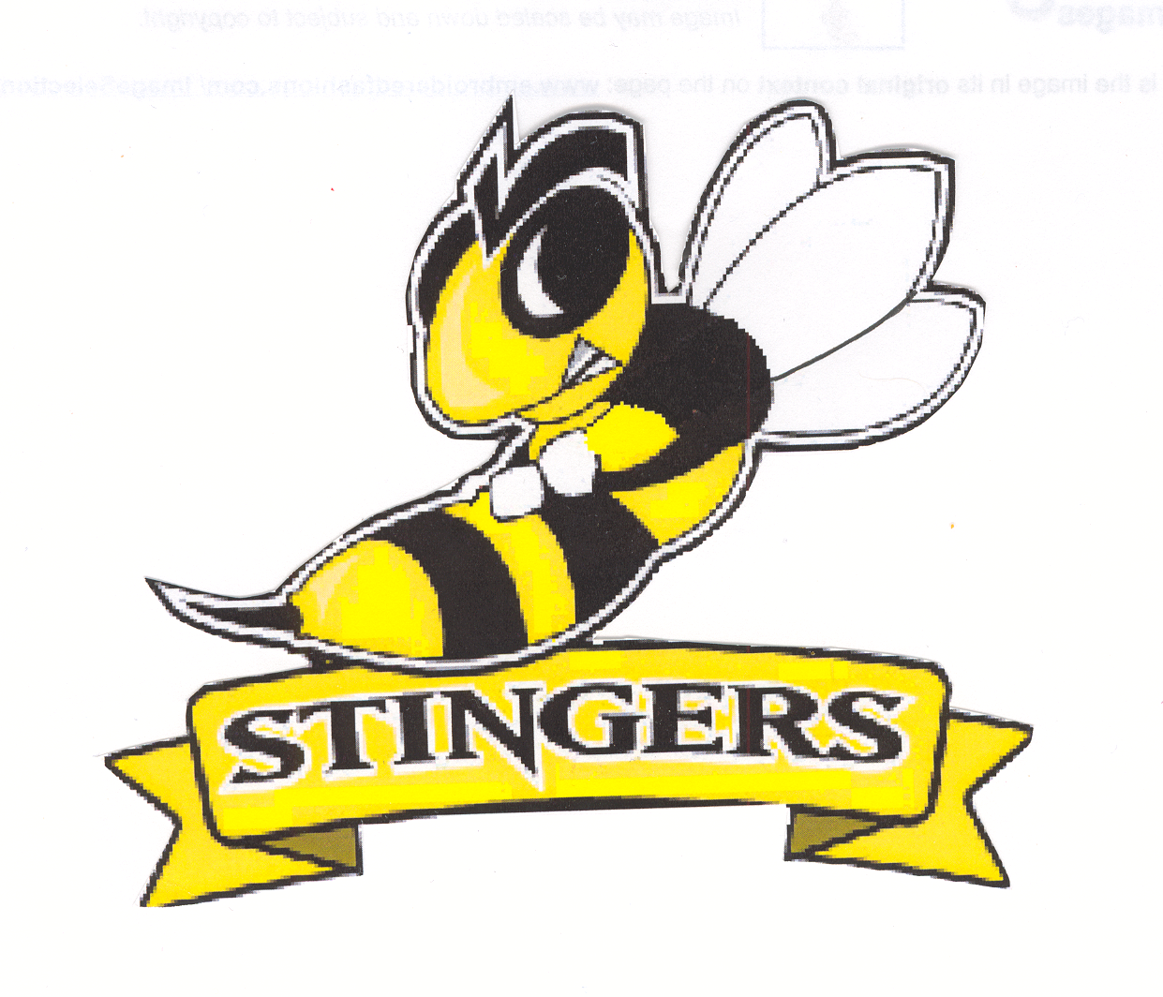
SR GIRLS
BASKETBALL TOURNAMENT

Consort Stinger Invitational Basketball Tournament
Feb 5-6, 2016.

The Senior Stingers would be happy to host your team at our invitational tournament this year. The plan is to run an Oregon Draw, guaranteeing each team 3 games. Entry Fee is $250. We welcome 1A, 2A and JV teams from larger schools.

Don’t hesitate to enter. Email me at Kevin.assenheimer@plrd.ab.ca. If you have questions please call 403 577 – 3654. I will call you back and confirm your entry.

Team Name:_____________________________

School: ____________________________

Coach / Contact: ____________________________

Phone:______________________ Fax _____________________

