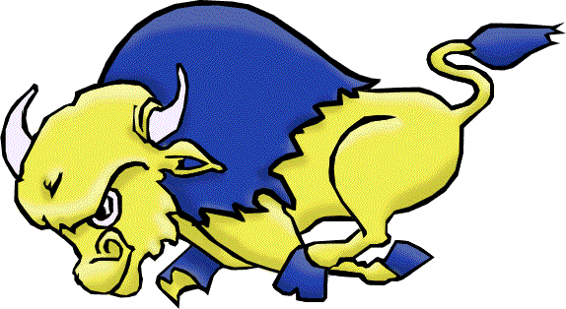
Brooks Buffalos Prairie Classic Basketball Tournament
Jan. 7th - 8th, 2022

Brooks Composite High School
Box 849 650 – 4th Ave. East, Brooks, AB T1R 0Z4
Phone: (403) 362- 4814 Fax: (403) 362-0169

Brooks Composite High School would like to invite you to enter the 2022 Brooks Buffalos Prairie Classic Basketball Tournament on Friday January 7th and Saturday January 8th, 2022. The tournament will consist of 8 girls teams running on an Oregon draw. If you are interested in attending please contact Mike Heninger (michael.heninger@grasslands.ab.ca)
Tournament Details
- each team guaranteed 3 games
- $375.00 team entry fee
- Team awards for 1st, 2nd, 3rd, & Consolation
- Player of the game awards
- Tournament MVP for the two finalist’s

Sincerely,
Mike Heninger

