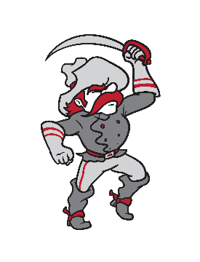

December 10/11, 2022

Welcome to the BATTLE RIVER BREAKOUT tournament hosted by Bashaw and Forestburg Schools. Enclosed you will find all pertinent information for the tournament including fees, concessions, rules, and awards. We hope this 16-team tournament is enough to get the rust off ahead of your seasons; more than this, we hope the experience is exceptional and that you and your players feel at home in our barns.

Best of luck,

Kyle McIntosh Jeff Rathwell Al Middleton
Tournament Organizer Tournament Organizer Athletic Director
Bashaw School Forestburg School Bashaw School

TOURNAMENT:

16-team draw; each team guaranteed 3 games. See attached draw for further information.

Rules:

- FIBA rules are in effect.
- 9 minute quarters, stop time.
- There will be a minimum five minute warm-up (if behind schedule) or 10 if on schedule.
- Half time will be five minutes.
- Please arrive 30 minutes early for your scheduled game time.
- Top of the draw wears LIGHT and is considered home.
- Overtime shall consist of a FIVE MINUTE interval with ONE time out.

Facilities Note: The host schools will always play in their own school. For instance, if Forestburg makes the final, they will be the host for the Championship game. In all other circumstances, per the tournament draw, Bashaw will host the Championship. This is a result of needing to complete site based work for which the hosts cannot be on the road. Please be aware of this as a condition for tournament participation.

Please bring your own warm-up basketballs.

Awards:
- Plaques awarded to 1st, 2nd, 3rd, and Consolation
- Additionally, medals will be provided to the championship team.

Concession:
Each facility has an on-site concession available for the duration of the tournament.

Please make cheques payable to Bashaw School in the amount of $375.00.

Please email us a copy of your roster as well as your school logo and name. This information is helpful for both our scoring table and for tournament promotion.

