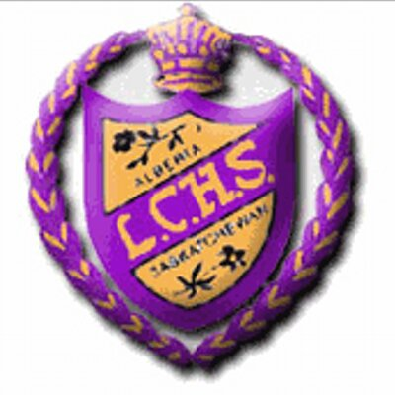
Junior Varsity Boys
Basketball Tournament
February 12th & 13th 2016

Hello Coaches,

On the weekend of February 12th and 13th the Junior Varsity boys’ basketball team will be hosting a tournament at Lloydminster Comprehensive High School. This will be a boys’ basketball tournament and are hoping for it being in an Oregon draw consisting of 8 teams and a guaranteed 3 games with player of the game awards and plaques for 1st, 2nd, 3rd and consolation winners.

The competition of teams expected from this tournament are junior varsity teams, 1A - 2A high school teams from Alberta and 1A – 3A teams from Saskatchewan.

Entry fee for the tournament is $275 and will be payable to LPSD. If you would like to ask questions or would like to confirm yourself for the tournament please e-mail kevin.sywenky@gmail.com or scott.lumbard@lpsd.ca

Thanks,
Kevin Sywenky
LCHS JV Boys Basketball Head Coach

