March 3 - 5, 2016
Ponoka Curling Club
Ponoka, AB

Hosted by:
Ponoka Secondary Campus

Tournament Chairperson Contact Information

Name: Holly Riske, Shawna Pearman
Address: Ponoka Secondary Campus
6100 – 54 Street
Ponoka, AB T4J 1N9
Phone: 403-783-4411
Fax: 403-783-5450
Email: holly.riske@wolfcreek.ab.ca or spearman@telusplanet.net
Tournament website: http://provincials.asaa.ca

Competition Site

Competition Site: Ponoka Curling Club
Address: 4410 – 54 Street
Date of Competition: March 3 - 5, 2016
The rink has 6 sheets of ice. The Ponoka Curling Club Lounge and concession are upstairs and can only be accessed from outside the building. There is limited viewing on the main level, but no seating. There will be an in-house concession available throughout the weekend.

Player/Team Registration

Please email your team roster, team picture and registration information (including # of banquet tickets needed) by 12:00 p.m. on Monday, February 29, 2016.

Registration will take place on Thursday, March 3rd from 1:00 p.m. – 4:00 p.m at the Ponoka Curling Club.

Banquet

The banquet is for players and coaches. There is also tickets available for parents/ guests. Deadline to order tickets is Mon, Feb 29th. Please include parent/guest tickets with your team registration information.
Dana Ferguson will be the Guest Speaker. A photo booth will also be at the banquet.

Date: Thursday, March 3, 2016
Time: 7:30 p.m.
Location: Royal Canadian Legion (3911 Hwy 2A, across from Western Budget Hotel)
Dress : Semi Formal

Registration and Banquet Fees

Please email your team registration information to Josh Boyd (josh@asaa.ca) and cc to Holly Riske (holly.riske@wolfcreek.ab.ca). Please make sure you have submitted a team roster, and team picture (for display on the website and for use in the program)
The entry fee is $130.00/team plus $1.00/player for ASAA Pay It Forward Loonie Fee. The banquet tickets are $27.00/person. Please bring your cheque with you to the registration on Thursday, March 3rd. You only need to write one cheque and it should be made payable to Ponoka Secondary Campus. (Does not include team pictures)

$______.00 Entry Fee ($130/team)
$______.00 ASAA Loonie Fee (# of players X $1)
$______.00 Banquet Tickets (# of tickets X $27) (Include parent/guest tickets with team)

$______.00 TOTAL

Photographs

The ASAA requires team photographs for their yearbook. All teams will have their pictures taken BEFORE they go on the ice for their practice. Athletes are asked to be dressed in team gear for the pictures. There will be an opportunity to purchase pictures at the event. Payment for team photos must be made with the photography company at the event and should not be included with the registration and banquet fees.

Coaches & Skips Meeting

There will be a brief meeting for coaches & skips on Thursday, March 3rd at 1:15 p.m. in the back room at Ponoka Curling Club. Please ensure you have both representatives at this meeting. Additional team members should remain in the lobby area.

Opening Ceremonies/Closing Ceremonies

The opening ceremonies will take place on Friday, March 4th at 11:30 a.m. at the Ponoka Curling Club. Please arrive 30 minutes before the ceremonies, so we can organize the teams. Athletes and coaches should come dressed in their uniforms and curling shoes. The opening ceremonies will follow the format below.

Zones and individual teams piped onto ice, led by the zone host.
O Canada
Athletes Oath
Welcome/opening remarks
Ceremonial Rock
Exit by following host.

The closing ceremonies will take place following bronze and gold medal games in the curling lounge.

Concession

The concession in the curling lounge will have a basic breakfast, lunch and supper menu. Available to all curlers, coaches and spectators. Complimentary meal tickets will be given to the coaches and officials for lunch and dinners to use at the concession.

Souvenirs

ASAA provincial clothing will be on sale FRIDAY, MARCH 4th only. See the Gimmics display in the hockey lobby downstairs to purchase championship clothing.

Water Bottles
Please ensure your athletes bring their own water bottles if they wish.

First Aid

Teams must bring their own medical supplies and plan to do their own taping. First Aid kits will be onsite for emergency purposes only.

Admission

There is no admission charge for this event. Tickets for a Twoonie Broom raffle will be available.

Accommodations

60 rooms have been blocked for this championship event at the Western Budget Motel for March 3 – 5th. Curlers and coaches have priority for the rooms, parents and family members must seek alternative hotel arrangements if there is no vacancy.

Western Budget Motel - 4205 - 64 Street 403-783-8382

Alternative Hotels:

Canalta Ponoka  403-704-1177 | Stampeder Inn  403-783-5535

Practice Times

Practices will begin at 10:30 am. Check for your practice times on the website.

Schedule

The complete schedule/draw can also be found online. http://www.asaa.ca/championships/site/2016-asaa-curling-championships-ponoka/draw
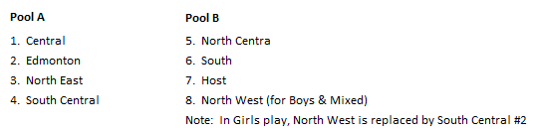
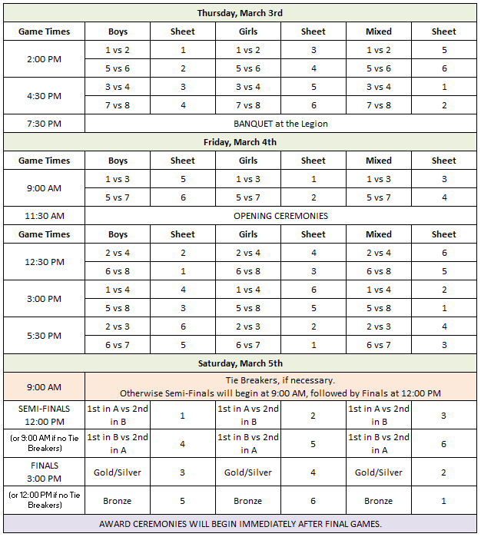

ASAA Code of Ethics

Fair Play and Sportsmanship
All competitions must be conducted with a high standard of courtesy, fair play and sportsmanship. All those involved share this responsibility.

A. Coaches
The coaches must demonstrate qualities of courtesy and good sportsmanship. These are evidenced by proper acceptance of officials’ judgment, positive encouragement of player performance and bench behaviour.

B. Athletes
Athletes must demonstrate qualities of courtesy and good sportsmanship by proper acceptance of officials’ judgment and by showing proper respect for opposing athletes as well as for teammates.

C. Cheerleaders
Cheerleaders must demonstrate courtesy and good sportsmanship by the appropriateness and timeliness of the cheers they lead, respect for the other cheerleaders and athletes, and their attempts at effective crowd control.

D. Spectators
a. Spectators, both student and adult, must demonstrate courtesy and good sportsmanship by positive cheers of encouragement for their team, not against the opposing team. This is evidenced by the absence of booing
and vulgarities. Spectators must also show proper acceptance of officials’ judgment. Artificial noisemakers are not permitted during provincial championship tournaments/event including: badminton, basketball, cheerleading, curling, golf, team handball, track & field, volleyball and wrestling. With the exception of air horns and electronic
megaphones, noisemakers are permitted at cross country, football and rugby. Prohibited noisemakers may include but are not limited to:
air horns, cow bells, plastic tube horns,garbage can lids, etc. The provincial championship host shall have the authority to eject from the competition facility individuals who, following a warning, refuse to comply with this requirement.
b. Eviction for Inappropriate Language and/or Behaviour. The Executive Committee or its host/designated representative shall have authority to direct any person to immediately leave any premises or venue hosting any ASAA sanctioned event if that person:
1. exhibits rude or abusive behaviour to any other person
2. uses vulgar, obscene or abusive language and/or gestures
3. fails to promptly follow any reasonable direction given to that person by the designated representative of the ASAA

The Executive Committee or its designated representative shall have the authority to notify local law enforcement personnel of the failure of any person to immediately comply with a direction to leave any premises or venue hosting any ASAA sanctioned event.

E. Administrators and Teachers
Administrators and teachers must demonstrate courtesy and good sportsmanship by their positive examples.

ASAA Curling Policy

A. Rules
1. The rules governing ASAA curling shall be the blended rules of the Canadian Curling Association, with
the following modifications:
a) Each team is permitted to take two 60-second time outs per game. The time outs must be taken when the team is in possession of the rock. They may be called by the skip or coach. The time outs cannot be carried forward to the extra end(s).
b) One 60 second timeout is available to each team for each extra end.
c) A five minute break is allowed after the 4th end.
d) In the event of a 4-end tie-breaker, one 60-second time out per team will be permitted.
2. ASAA provincial competitions shall use the four rock free guard zone rule currently used by the Canadian Curling Association.

B. Season of Play
The season of play for curling shall be October 1 to the provincial championships on the first Friday and Saturday in March. The season of play is not intended to include July and August. See SECTION V – ACTIVITIES, Item C, pages 55-57 for more information.

C. Eligibility
1. Each high school team will be allowed not more than two high school students who have advanced to provincial junior men’s or women’s championships. The rationale for this is to allow more students the chance to experience competition at a provincial level. Note: At present, there are eight rinks that advance to both the provincial final in junior men’s and women’s championships.
2. Schools are required to submit the names of their curling athletes in ExNet by the registration deadline. All students on the curling team are eligible to compete on any of the school curling teams; however, the athletes that play together at all qualifying events for provincials (e.g., districts, zones) are the ones that form the team that moves on to the provincial competition.
3. Each boys and girls team will consist of five students and mixed teams will consist of six students. Mixed teams shall comprise two girls and two boys, with girls and boys alternating at the various team positions.
4. Only one team per category may compete per school.

D. Teams
1. All games must be started with the rink having four players. Any rink not having its full complement of four players shall be disqualified. If a player withdraws from play and there is no substitute, the first two curlers will throw three stones, with the skip throwing two stones. No rink may continue to play with fewer than three players.
2. Substitutions may be made during or between games by using the non-playing team member(s) for any team positions (in mixed play, a boy can only be substituted for a boy, and a girl for a girl, following C.2. above). In mixed play, if a substitute of the correct gender is not available then the team will continue the game with three players in their existing order, throwing 3, 3, and 2 stones. All team members must meet ASAA eligibility equirements and cannot be members of other school representative curling teams as established at the qualifying events for provincials (see C.2. above). All teams must continue throughout the competition with the listed team members as constituted in the first post-district game of the competition.

E. Events
1. Format
a) Each provincial competition shall be an eight team spiel with each zone having one entry in each of the three categories.
b) All games will be eight ends duration. If tied at the completion of eight ends, an extra end or ends shall be played.
c) Competition in each event shall be two section round robins. At the completion of the round robin, the first place team from each pool will play the second place team from the opposite pool. The winners play to determine the gold and silver medal winners, and the losing teams play to determine the bronze medal winner.

2. Hammer
Determining which team gets last rock advantage ("hammer") to start the game will be done as follows:
a) round robin and tiebreaker games - coin toss between thirds to determine
b) 1 vs 2 crossover playoff game - the team which finished first in their pool will be rewarded with hammer in this game.
c) medal round games - the better draw to the button measurement, which was done after the first game, will determine hammer.

3. Tiebreakers
a) If two teams are tied for first, the game between the two teams will determine first and second place.
b) The tie-breaking procedure will include a draw to the button to take place after the conclusion of the first game, by all teams involved in the competition. Teams may select any player to deliver the draw to the button. One practice rock will be thrown and sweeping will be allowed.
i. If three teams are tied for first, the team with the rock closest to the button will be awarded 1st place in the pool. The other two teams will play a four-end game to determine the 2nd place team. Extra ends will be played if necessary.
ii. If three teams are tied for second place, the team with the rock closest to the button will be awarded a bye. The other two teams will play a four-end game with the winner then playing the team with the bye in another four-end game to determine 2nd place in the pool. Extra ends will be played if necessary.

Sportsmanship Awards

Sportsmanship pins will be given to individuals who exhibit outstanding displays of integrity, fair play and good sportsmanship. Sportsmanship pins may be given to players, coaches, parents and spectators. These individuals will be recognized for bringing a positive presence to the championship and demonstrating consistent exemplary sportsmanlike behavior. If you see outstanding displays of sportsmanship, bring an informal nomination forward to any one of the organizing committee members.

Curling Sportsmanship Team Awards are presented to one team from each of the girls, boys and mixed events. Each team member is presented with an ASAA sportsmanship pin to commemorate their achievement, along with the team banner and sportsmanship plaque, which will be sent from the ASAA office within the weeks following the event.
These awards are selected by the sportsmanship committee members. The team sportsmanship award selection will also have the input from participating teams.

Grievance Committee Purpose: There are two key functions of the Grievance committee at ASAA provincials. The first function is to deal with matters that occur during competition, typically discipline/conduct types of issues, and appeals that may arise from ejections, while the second function is to handle any other matters that arise that require dispute resolution.

Coaches will be informed of who is sitting on this committee during the coaches meeting.

