Tier 2 Rugby Provincials
2017

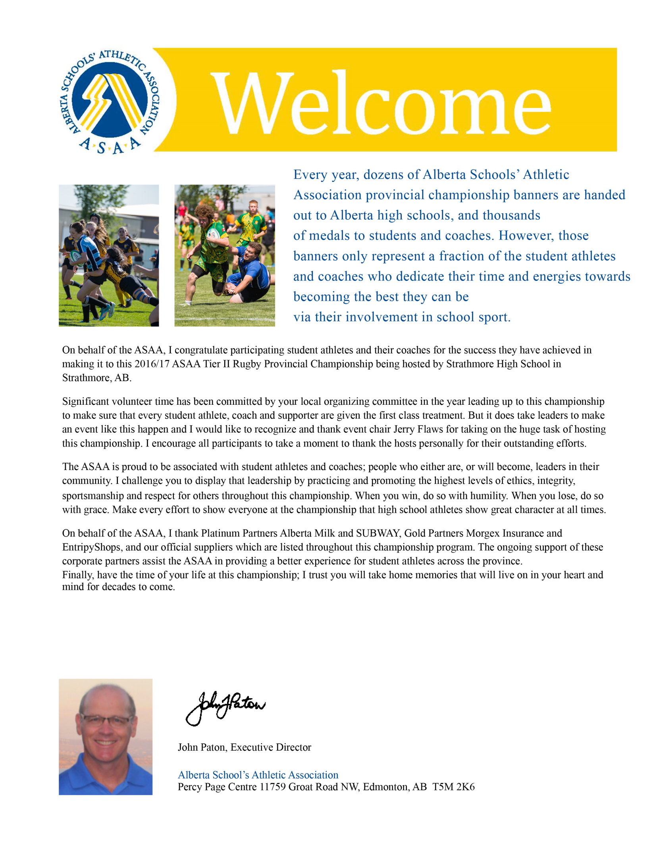
Dear Athletes, Coaches, Parents
Welcome to the ASAA Rugby Provincials being hosted by Strathmore High School. On behalf of our students and staff, I would like to welcome you to Strathmore and to this year’s provincial championship. The hard work and sacrifice that you have put into the season has already been rewarded by being your zones representative here at provincials. I would like to thank all the coaches and volunteers who have put in countless hours of time this past season. It is this commitment to sport that ensures the season and provincial championship is a huge success.
Congratulations to all the teams on a successful season and we wish you the very best at the provincial championship this weekend. Good luck!
Sincerely,

Kyle Larson

Principal
Strathmore High School

Tournament at a Glance

Friday June 9th, 2017
- 10:00 Tier 2 Girls Quarter final (Brief opening Ceremony SHS field)
- 11:00 Tier 2 Girls Quarter final
- 12:00 Tier 2 Boys Quarter final
- 1:00 Tier 2 Boys Quarter final (Brief opening Ceremony SHS field)
- 2:00 Tier 2 Girls Semi-Finals
- 3:00 Tier 2 Girls Semi-Finals
- Team Pictures and Meals 3:00-7:30
- 4:00 Tier 2 Boys Semi-Finals
- 5:00 Tier 2 Boys Semi-Finals

Saturday June 10th, 2017
- 10:00 Tier 2 Girls Final Games
- 11:30 Tier 2 Girls Final Games
- 1:00 Tier 1 Boys Final Games
- 2:30 Tier 1 Boys Final Games

Rugby 101: The Basics

With 15 players per side, a rugby team is divided into forwards and backs. Forwards are usually the larger, stronger players on the team. Their main job is to win possession of the ball. The backs are often smaller, faster, and more agile and typically exploit the ball possessions, which are won by the forwards.

Both the forwards and backs play at the same time. All 15 players assemble on the field, called a pitch, and the match starts with a kickoff. The receiving team generally tries to move the ball downfield to score. However, in attempting to score, the team cannot pass the ball forward. The defenders can only tackle the ball carrier.
After the ball carrier is tackled, there is a scramble for the ball. Hence, a tackle does not stop play in rugby. Once tackled, the player must release the ball immediately so play may continue. The tackled ball carrier should attempt to

release the ball advantageously toward his or her team. Still alive, any player may pick up the ball. When players from both sides fight for the ball when it is on the ground, the situation is known as a "ruck." This can be described as the most dynamic action of the game. The team that retains ball possession during tackles and ensuing rucks has an advantage over the other team.

Sometimes the ball is buried during a tackle, or a player commits a minor infraction of the laws (a penalty). If the team that has not offended doesn’t first gain an advantage from the continuance of play, the referee will stop play and call for a scrum to restart the match. The non-offending team has the advantage of putting the ball into the scrum and, therefore, will most often win possession.

During a scrum the ball must be worked backwards, and the player’s hand cannot touch the ball in the scrum. When the ball emerges, open play resumes. The remaining players who are not involved in the scrum must stay behind their respective offside line.

Once a team has worked the ball downfield and crossed the opposing team’s goal line, and forced the ball onto the ground with downward pressure, a try is scored. Each try is worth five points. After each try, the scoring team has the opportunity to score two more points with a conversion.
Both teams play to score tries during two 40-minute halves.
http://www.calgaryrugby.com/

The Pitch & The Players
The field that rugby is played on is called a pitch. The pitch is expected to be 100 meters long by 69 meters wide. The sidelines are called touchlines and there are two in-goal areas, which are expected to be 10 to 22 meters deep with a tryline marking the front and a dead ball line at the back. The goal posts are located on the try line and are 5.6 meters apart with a crossbar set at 3 meters. The height of the posts varies according to the club's wishes.
Other important lines on the pitch include the half way mark at 50 meters. A dashed 10 meter line set each side of the 50 metre line, which is used to judge kickoffs, and a solid 22 meter line marked 22 meters from each tryline. Other lines include two dashed lines set at 5 and 15 meters marked parallel to each touchline. These lines are used mostly to identify the zones for lineouts.
Rugby union is played in different variations depending on the number of players on the field for each team. The typical game is played with fifteen players per side and lasts 80 minutes, with 40 minutes being played in each half. An abridged version is also very popular but is played with seven players per team over two seven minute halves. A less often played version is called tens and is played with ten players per side.
http://www.calgaryrugby.com/

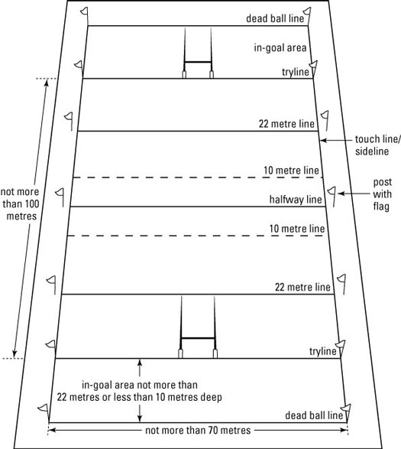

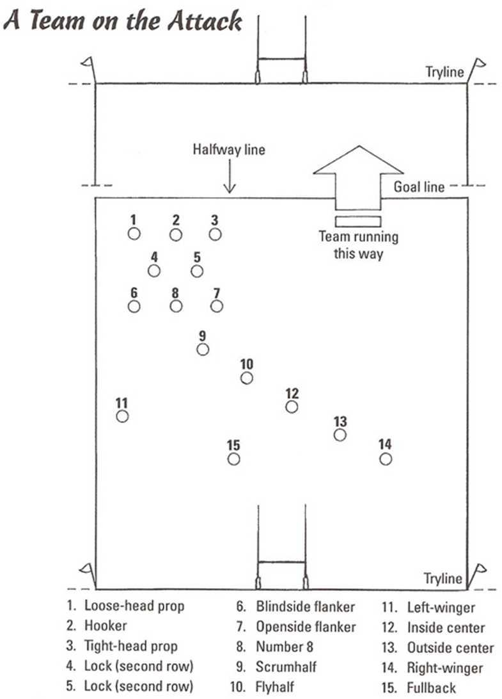

Tier 2 Girls ASAA Rugby Provincials
SHS Field 100 Brent Blvd Strathmore CHS Field 241078 Highway 791 Rocky View No. 44

 |  |  | (S)Winston Churchill
SHS Field
Fri. 10:00 am
 |  | CHS Field  Fri 2:00 pm | (NW) St. Joseph | CHS Field  Fri 3:00 pm
 |  |  | (Cen) Hunting Hills
CHS Field
Fri. 10:00 am
 | CHS Field |  | (Cal) St. Mary’s |  | SHS Field
Consolation Champion | Sat. 10:30 am |  | (Edm) Sturgeon |  | Sat. 10:30 am | Provincial Champion
Field TBA
Fri. 11:00 am
 |  | SHS Field  Fri 2:00 pm | (SC) Strathmore | SHS Field  Fri 3:00 pm
 |  |  | (NE) Lloydminster
Field TBA
Fri. 11:00 am
 |  |  | (SC) Bow Valley
 | CHS Field |  |  |  | SHS Field
7th Place | Sat. 9:00 am |  |  |  | Sat. 9:00 am | Bronze Medal

Grade Sr. Girls
10 Aiden McBean
12 Amanda Rande
12 Autum Desjardin
11 Becky Driver
12 Brianna Kennedy
10 Brooke Fandry
10 Brooklyn Shea
12 Camryn Dimion
11 Danielle M orrison
12 Darcey Weir
10 Emma Marleau
11 Emma Bear Chief
10 Erin Reynolds
11 Georgia Nobling
11 Harmony McDonald
11 Jessica Turner
12 Julia Alameda
12 Kaeleigh Coull
10 Kaila Estall
11 Kaitlyn Stewart
11 Kallie Little Bear
10 Kat Langlois
12 Katelyn Knight
11 Kayla Lihaven-Hazell
11 Kayley Bingham
12 Kelsi Johnson
11 Kiara Allan
12 Lena Frohlingsdorf
10 Mckenna Blades
12 Nzinga Tankam
12 Pacey Means Strangling Wolf
12 Paige Skrypnek
12 Raeanne Pettifer
12 Sam Treacy
10 Sarah Woods
10 Sarah McNeill
12 Shayla Walker
10 Sydney Phillips
12 Tanya Shpyth
12 Yulisa Solda
Coaches: Jerry Flaws, Claire Berenger, Keenan Fanning

Foothills Composite High School

Bass, Cassidy
Bodry, Delijiah
Boone, Chloe
Borrego, Melody
Brook, Rosie
Brown, Tori
Carlson, Reilly
Cooper, Janae
Crawford, Abby
Curtis, Annaliese
Dicks, Madison
Dressel, Shaylee
Eagleton, McKenna
Fenner, Tara
Fenske, Keelin
Fieldler, Maddi
Gibson, Nicole
Gitterman, Cara
Groome, Brooke
Hamilton, Hanna
Hogan, Kaitlyn
Jeanson, Jadyn
Jensen, Megan
Juhasz, Ashley
Kellogg, Jazmyn
Krauss, Rylee
LeLonde, Krystal
Little, Larissa
Lowry, Paige
McAnally, Ireland
McCarthy, Eden
Poole, Kate
Robstad, McKenzie
Shirakawa, Claire
Stasiuk, Landry
Stasiuk, Marley
Stephan, Abbigail
Stephan, Laurel
Sutton, Mackenzie
Uhlenberg, Rebecca
Vandergag, Morgan
Van Rooyen, Kerryn
Wangkhiree, Luknan
Waldner, Lauren
Wayne-Nixon, Gillean
White, Shaylon
Zacaruk, Nicole
Zylstra, Chantel

Lloydminster Comp
Player | Number | Position
Emily Newsham | 21 | 8th
Janel Millar | 7 | Center
Amanda Burris | 28 | Prop
Miranda Rendle | 9 | Wing
Chloe Sperounes | 4 | Flanker
Brenna Nelson | 11 | Scrum Half
Brooke Jory | 20 | Locke
Bailee Werstroh | 3 | Center
Day Ewen | 8 | Center
Jordan Ganton | 27 | Prop
Rhianna McCaffrey | 15 | Prop
Lindsy Boisson | 10 | Standoff
Paige Dembicki | 1 | Hook
Jocelyn Kay | 12 | Prop
Abbi Joy | 5 | Wing
Mekwan McAdam | 2 | Full back
Hannah Greening | 13 | Flanker
Shan Camado | 24 | Wing
Brianne Gladstone | 14 | Prop
Olivia Reidel | 6 | Wing
Samantha Gottinger | 18 | Wing
Sam Cavanaugh | 19 | Wing
St. Mary’s Senior Girls Rugby
Charlotte Neander
Alix Devlin
Cynthia Milan
Shekinah Mpoy
Solana Pasqual
Maria Jose Ruiz
Maria Fernanda Ruiz
Robee Baydid
Karla Tejada Iglesias
Holly Rogers
Kyera Rampersaud
Ivanna Rodriguez Vargas
Rica Mae Aldos
Sarah Blott
Catriona McFadden
Rachele Polinelli
Jordan Zwarych
Afua Frempong
Valeria Barrera
Gina Woodward
Emily Chiasson
McKenzie Elliott
Lourdes Furagganan
Ximena Barrera
Isabella Lea
Monica Castaneda
Leila Saban
Clara Laperche
Goodwin Cesaire
Eva Odosa
Clarissa Lazo
Ange Tamdem
First Name | Last Name | Jersey # | Position # | POSITION
Elise | Bluett | 2 | 2 | Hook
Maddie | Butler | 1 | 1 | Prop
Kayden | Byrtus | 13 | 16 | Centre
Chanel | Demas | 22 | 17 | Prop
Dakota | Evans | 6 | 7 | Flank
Sara | Fischer | 3 | 18 | Prop
Sarah | Fraser | 11 | 14 | Wing
Kandra | Hayter | 24 | 9 | Scrum Half
Camryn | Holland | 7 | 6 | Flank, Hook
Tori | Hoppus | 8 | 3 | Prop
Keyanna | Jones | 25 | 20 | Sub-Flank
Kirsten | Kehler | 17 | 21 | Sub-Lock
Sidney | Kozelenko | 10 | 13 | Centre
Jessie | Lanceleve | 5 | 19 | Sub/Prop/Flank
Julieta | Martin Martell | 19 | 4 | Lock
Tess | Mclachlin | 18 | 12 | Centre
Morgan | Miller | 20 | 22 | Sub/Flank
Mackenzie | Partridge | 12 | 15 | Full Back
Zoeanna | Pilgrim | 21 | 19 | Scrum Half
Jamie | Siller | 14 | 11 | Wing
Sarah | Stahl | 15 | 10 | First Receiver
Olivia | Watson | 9 | 5 | Lock

 | Wiston Churchhill High School
# | Last name | First name | Position
1 | Sikking | Sydney | Prop
2 | Small | Kaitlynn | Hooker
3 | Greeno | Rachel | Prop
4 | Ridder | Jamie | Lock/Prop
5 | Rombough | Kaitlyn | Lock
6 | Therien | Eloise | Flanker
7 | Lashley | Jayden | Flanker
8 | Carter | Nicole | #8
9 | Kruchkywich | Tyler | Scrum Half
10 | Kenney | Roxy | Flyhalf
11 | Toth | Sydney | Wing
12 | Vanderhulst | Hannah | Center
13 | Funa | Maile | Center
14 | Whillans | Kasydi | Wing
15 | Needham | Shelby | Fullback
16 | Wills | Joelle | Flanker
17 | Gertridge | Kyra | Wing/Center
18 | Terrazano | Rosie | Scrum Half
19 | Han | Amy | Flanker
20 | Neil | Emilie | Wing
21 | Khadka | Saraswati | Lock
22 | O'Connor | Jesse | Wing
23 | Creig | Megan | Prop
 | Metz | Skyla

Sturgeon Composite High School Senior Girls Rugby
2 | Samantha Mullin | Hooker
3 | Josie Middleton | Wing
9 | Mackenzie Hamm | Flank
10 | Geena Kieftenbeld | Fly-half
11 | Morgan Soetaert | Center
12 | Chloe Deck | Lock
13 | Katarina Boras | 8 Man
14 | Megan McKee | Prop
16 | Angelica Ramos | Wing
17 | Ryann Hedstrom | Center
18 | Deanna Thimer | Lock
20 | Kayla Zureski | Flank
21 | Makenna Chappell | Lock
22 | Kaylin Charboneau | Lock
23 | Jamie Zureski | Prop
24 | Mikaelee Watrin | Flank
26 | Shelby Pierce | Prop
29 | Kianna Kozak | Scrum-half
30 | Tayler Onofrichuk | Hooker
32 | Lili Guglich | Wing
33 | Riane Vallin-Maclean | Scrum-half
34 | Brynn Hoffart | Center
35 | Ceili Davey | Fullback
36 | Grace Arndt | Fullback
70 | Emma MacDonald | Hooker
71 | Ashley Holden | Lock
72 | Caitlyn Daigle | Center
73 | Cecile Rosychuk | Prop
74 | Janessa Doctor | Wing
93 | Shae Savoie | Wing
 | Stacie Becker | Coach
 | Tricia Hamm | Coach

Roster

1- Taylor Manns (prop)
2- Denysse Garcia (hooker)
3- Shaelin Ginther (prop)
4- Laurel Noonan (lock)
5- Logan Thomas (lock)
6- Cassidy Taylor (flanker)
7- Chaeli Cowan (flanker, 8)
8- Stasha Lysyk (8, prop)
9- Dazlyn Anderson (scrumhalf)
10- Payton Viney (flyhalf, scrumhalf)
11- Tory Smith (wing)
12- Taryn Kustra (centre, wing)
13- Kirsty McFayden (centre, fullback)
14- Miranda Drollinger (lock, wing)
15- Liz Orr (fullback, wing)
16- Haley Solowoniuk (wing, flanker)
17- Jayden Sims (wing, centre)
18- Elizabeth Abramenko (wing)
19- Megan Hanna (wing)
20- Robyn Beattie (flyhalf, centre, wing)
21- Mikayla Surmik (prop, 8)
22- Rebecca Amokwandoh (lock, prop, flanker)
23- Taylor Smith (flanker, wing)
24- Autumn McEntauffer (hooker)
25- Hayley Smallbones (prop)

Tier 2 Boys ASAA Rugby Provincials
SHS Field 100 Brent Blvd Strathmore CHS Field 241078 Highway 791 Rocky View No. 44

 |  |  | (S)Winston Churchill
SHS Field
Fri. 12:00 pm
 |  | CHS Field  Fri 4:00 pm | (NW) St. Joseph | CHS Field  Fri 5:00 pm
 |  |  | (Cen) Westaskiwin
CHS Field
Fri. 12:00 pm
 | CHS Field |  | (Cal) Henry Wise Wood |  | SHS Field
Consolation Champion | Sat. 1:30 pm |  | (Edm) Sturgeon |  | Sat. 1:30 pm | Provincial Champion
Field TBA
Fri. 1:00 pm
 |  | SHS Field  Fri 4:00 pm | (SC) Strathmore | SHS Field  Fri 5:00 pm
 |  |  | (NE) Lloydminster
Field TBA
Fri. 1:00 pm
 |  |  | (SC) Bow Valley
 | CHS Field |  |  |  | SHS Field
7th Place | Sat. 12:00 pm |  |  |  | Sat. 12:00 pm | Bronze Medal

PLAYER NAME | JERSEY NUMBER | POSITION
Dalton Anderson-Sharples | 31 | Back
Jared Aschenbrenner | 7 | Forward
Riley Bradford | 30 | Back
Martin Cheung | 18 | Back
Riley Cox | 2 | Forward
Rad Derrick | 16 | Back
Thomas Derrick | 22 | Back
Cooper Fargey | 6 | Forward
Wyatt Haegele | 37 | Forward
Connor Hay | 17 | Back
Jayden Presley Kiernan | 25 | Back
Jonathan Le May | 13 | Back
Aaron Maudsley-Tetz | 19 | Forward
Ben Mertz | 4 | Forward
Joey Pattison | 3 | Forward
Gunnar Raycroft | 11 | Back
Chris Rebeyka | 12 | Back
Avalon Rosario | 9 | Back
Isaiah Simwamu | 15 | Back
Jassjot Singh | 38 | Forward
Dustin Thiessen | 5 | Forward
Reid Van Eaton | 10 | Back
Misi Varga | 8 | Back
Isaac Wegner | 14 | Back
Tyler Welsh | 35 | Forward
Kashtin Winnipeg | 1 | Forward

1. Colten Boyle | BV | * | flanker, prop
2. Harry Carter | BV | * | center
3. Jack Carter | BV | 3 | tight head prop
4. Thomas Cameron | BV | 13 | outside center
5. Graeme Cockwill | BV | * | 2nd row
6. Sean Crawford | CHS | * | wing
7. Spencer Crawford | CHS | 20 (4) | lock
8. Craig de la Mare | CHS | 8 | 8
9. Karl Gildemeister | BV | 1 | loose head prop
10. Dylan Gingrich-Hadley | CHS | 6 | flanker
11. Jamal Grant | CHS | 14 | wing
12. Alek Halwas | CHS | * | center, fullback
13. Jack Hindley | BV | 5 | lock
14. Cole Hughes | BV | INJ | injured (not playing)
15. Jadon Kibzey | BV | INJ | injured (not playing)
16. Keenan McElroy | CHS | * | fullback, wing
17. Rollie Miller | BV | * | scrum half
18. Logan Nadorozny-Arns | CHS | 9 | scrum half
19. Kirk Palmer | CHS | 15 | fullback, wing
20. Jordan Pease | BV | 2 | hooker
21. Anthony Popescue | CHS | * | hooker
22. Jordan Popoff | BV | * | 2nd row
23. Thomas Powley | BV | 12 | inside center
24. Lloyd Rodgers | BV | 7 | flanker
25. Austin Strang | CHS | 11 | wing
26. Rylen Waugh | BV | 10 | fly half
27. Garrett Peers | BV | * | 2nd row
28. Dylan Rieberer | CHS | * | 2nd row, flanker

Wetaskiwin

Alex Correia
Austin Couto
Bennett Brand
Benson Pitcher
Caden Maplethorpe
Eduard Frye
Gavin Hetzner
Hayden Cullen
Jake Gusse
Jacob Dormaar
Jan Oliver Munoz
Jeffery Oliver
Jesse Senz
Jonas Crier
Justin Warnke
Michael Leeb
Brian Pinaso
Ryden Emmerling
Jake Emmerling
Samuel Siemens
Stephan van Dyk
Tyson Fiveland
Kyle Kirwer

Coach: Hannes Brand
Manager: Louize Brand
STURGEON COMPOSITE SR. BOYS RUGBY ROSTER 2017
Name Position Number
Cooper Kenda Wing 0
Deven Quintal Wing 1
Chase Kobza Fullback 5
Nick Reed Injured 2
Samuel Kaup Scrumhalf 8
Noah Bohaychuk Stand Off 12
Aiden Westra Flank 13
Ryan Nikiforik Hooker 14
Tanner Stefanik Prop 23
Cohen Leibel Outside Center 25
Kayden Pool Hooker 27
Griffen Perrott Inside Center 28
Jamie Crowther Fullback 29
Klay Mcdonell Flanker 36
Noah Vanbrabant 2nd row 37
Dawson Brenneis 2nd row 38
Anthony Candiani Prop 44
Curtis Vos Injured 61
Tyler Holden Prop 56
Wesley Kieftenbeld Wing 57
Rory Mckenzie 2nd row 58
Cole Cameron 8 man/Scrum half/2nd row 60
Simon Clouthier 2nd row 65
Ryan Young 8 man 66
Bailey Parno 8 man/ Wing 67
Cole Rogers Full back 68
Levi Kaulkman Wing 70
Quade Kozak Outside center/ Inside center 71
Henry Wise Wood High School Senior Boys Rugby Roster 2017 - ASAA

NAME | POSITION
Arka Banerjee | Lock
Calum Breen | Lock
Jake McCaw | Prop
Zac Elphicke | Wing
Quaid Cunningham | Hooker
Mike DeBiasio | Wing
Thomas Bradbury | Lock
Justin Clarke | Prop
Jason Lamey | 8man
Josh Onespot | Prop
Brody Robertson | Center
Brenden Trenchuk | Scrumhalf
Ryan Waeyen | Center
Mac Cook | Wing
Matson Tulloch | Center
Curtis Carmichael | Fullback
Will Collison | Lock
Stephen Palmer | Flanker
Mike Mourelatos | Flyhalf
Nate Mendoza | Flanker
Justin Leger | Prop
Logan Young | Wing
Coaches: Brent P. Gough

First name | Last name
Keegan | Beaudoin
Dillon | Bexson
Gabriel | Bilodeau
Dorin | Clough
Logan | Dobko
Kieran | Eidse
Kyle | Gordey
Devin | Green
Kaleb | Johnstone
Liam | Johnstone
Joel | Manz
Chris | MacDougall
Jordan | Maddigan
Tanner | Morris
Michael | Penney
Zachary | Ruptash
Daylen | Sliger
Tristan | Taylor
Dylan | Thomson-Smith
Marshall | Tunke
Jeremey | Way
Jared | Wetzel
Bennett | Winnicky-Lewis
Silas | Yelenik

Lloydminster Comp
Name | Position | Number
Belly, Logan | Prop/Lock | 4
Bendick, Greg | Flanker | 7
Borzel, Jesse | Center | 13
Dykstra, Colton | WIng | 23
Falcon, Diego | Flanker/Scrum | 6
Henri, Chase | Prop/Lock | 3
Hodder, Gavin | Full Back | 15
Hodgson, Darian | Fly Half | 10
McLaughlan, Jay | Center | 13
Naive, Lance | Prop/hooker/ lock | 17
Parke, Robert | 8 man | 8
Patton, Reice | 8-man/lock | 5
Pinske, Landon | Wing | 14
Pollard, Scotty | Hooker | 2
Gage Renton | Wing/ center | 20
Svendson, Thomas | Wing | 11
Tucker, Mackenzie | Wing/center | 18
Walter, Adam | Wing | 22
Welz, Zach | Scrum Half | 9
Leith McEwen | Full Back | injured
2017 Winston Churchill High School Bulldogs
Name | Number | Position
Bukuru, Babu | 7 | Flanker
Greenwood, Noah | 15 | Fullback
Henderson, Connor | 10 | Fly Half
Marquinas, David | 9 | Scrum Half
Odeiwantumi, Paa Kwesi | 14 | Wing
Reyna, Gabe | 18 | Hooker
Stern, Dawson | 23 | Fullback
Adams, Sean | 13 | Center
Ceron, Keanen | 20 | Wing
Czarny, Sebastian | 1 | Prop
DeLauw, Nolan | 12 | Center
Durling, Justin | 16 | Prop
Elder, Blayze | 8 | #8
Mason, Taylor | 3 | Prop
Passey, Matt | 2 | Hooker
Peters, Josh | 5 | Lock
Povey, Nathan | 11 | Wing
Pritchart, Teagan | 17 | Flanker
Stewart, Matt | 6 | Flanker
Boenn, Yanis | 24 | Fly Half
DeHeer, Riley | 4 | Lock
Herbison, Jeff | 19 | Flanker
Borho, Adam | 22 | Wing

