ASAA 2019 Provincial Cross-Country Running Championship TOP 10 Junior Females
Place | Name | School | TIME
1 | EVONNE HENNING | Holy Trinity Academy | 17:16
2 | ELENA ESPOSITO | WESTERM CANADA | 17:37
3 | SAMARA COCKBURN | STRATHCONA | 17:40
4 | JORJA WILLIAMS | PARKLAND COMPOSITE | 17:55
5 | TOKI TSUZUKI | WILLIAM ABERHART | 18:16
6 | ASHLEY WHITAKER | WESTERM CANADA | 18:24
7 | KEIRA WORSEY | RAYMOND | 18:25
8 | ROBYN ASTRIDGE | WESTERM CANADA | 18:34
9 | CADENCE LAPLANTE | HOLY TRINITY ACADEMY | 18:48
10 | KATIE FREEMAN | STRATHCONA | 18:50

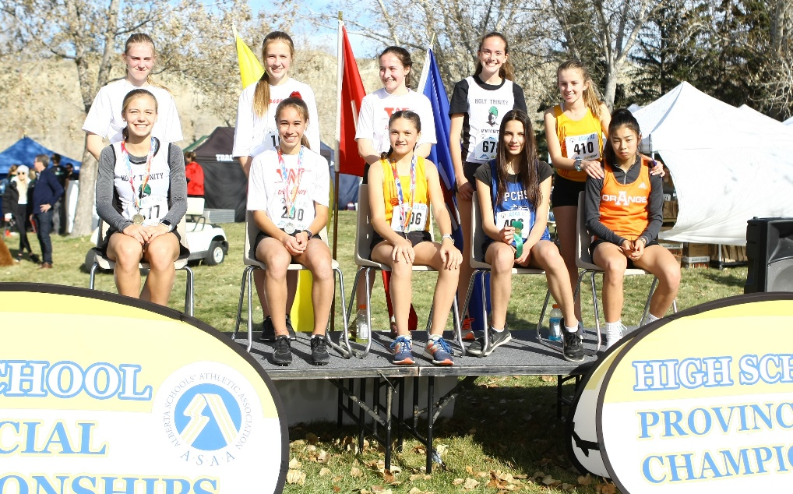
ASAA 2019 Provincial Cross-Country Running Championship TOP 10 Junior Males
Place | Name | School | TIME
1 | ISREAL BEZOOYEN | HARRY AINLAY | 15:00
2 | KIERAN SCHMIDTKE | LETHBRIDGE COLLEGIATE | 15:09
3 | CHRISTIAN SCHMIDT | STRATHCONA | 15:25
4 | LIAM OUELLETTE | STRATHCONA | 15:30
5 | ELSAMI ROSA MOLINA | ME LAZERTE | 15:44
6 | TERRELL KEYS | CENTENNIAL HS | 15:45
7 | FRIEDRICH FASZER | STRATHCONA | 15:48
8 | LIAM TINWORTH | ST. JOHN PAUL II | 15:49
9 | SHAUN GEUSEBROEK | PARKLAND IMMANUEL CHRISTIAN | 15:51
10 | MATTEO CAPELLANO | RUNDLE COLLEGE | 15:58

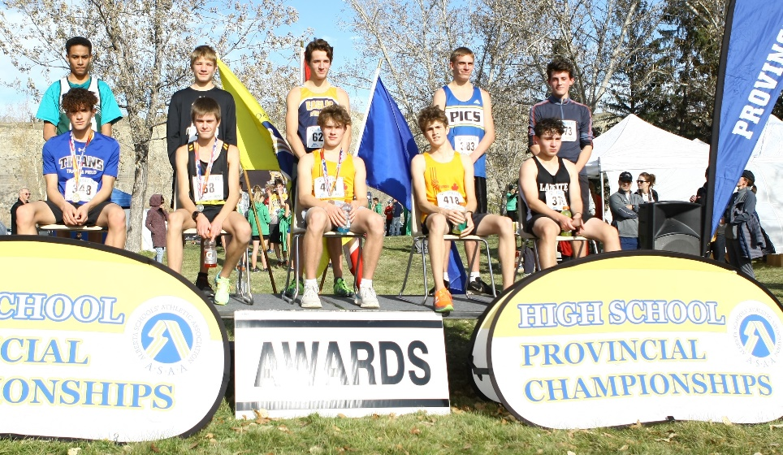
ASAA 2019 Provincial Cross-Country Running Championship TOP 10 Intermediate Females
Place | Name | School | TIME
1 | SADIE SIGFSTEAD | STRATHCONA | 20:27
2 | ERIKA CUNNIAM | FOOTHILLS COMPOSITE | 20:54
3 | ELLA CLAYTON | BISHOP GRADIN | 21:21
4 | SIHAAM KHALID | JOHN F. DIEFENBAKER | 21:29
5 | DARCI PETERSEN | ST. TIMOTHY | 21:45
6 | JENICA SWARTZ | LACOMBE | 22:09
7 | BRYNN HEBERT | WETASKIWIN | 22:30
8 | HOLLY MOORES | ST. TIMOTHY | 22:52
9 | COURTLYND CHERPIN | LETHBRIDGE COLLEGIATE | 23:02
10 | KENNEDY RICE | W.H. CROXFORD | 23:32

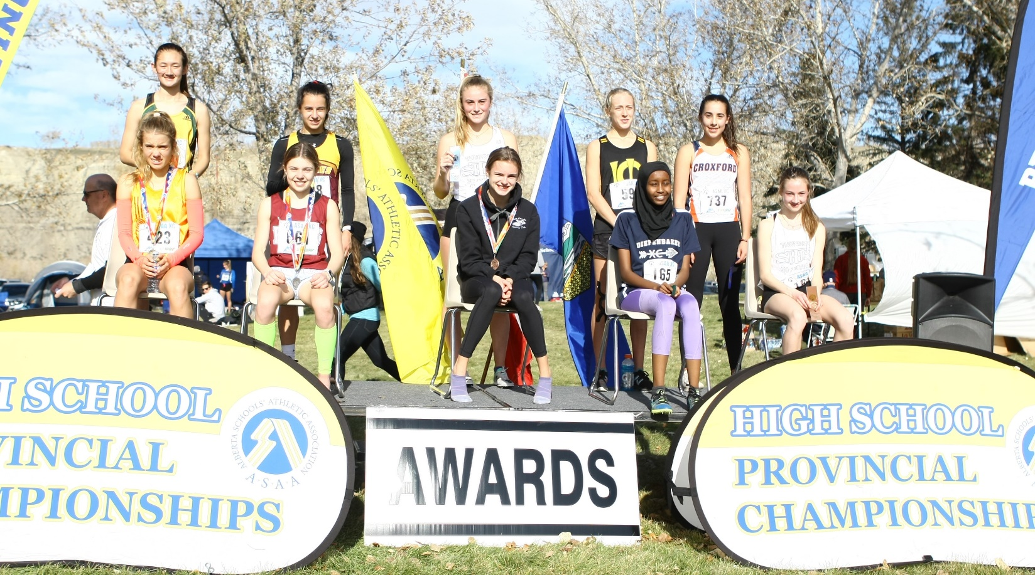
ASAA 2019 Provincial Cross-Country Running Championship TOP 10 Intermediate Males
Place | Name | School | TIME
1 | NEBIL MOHAMMEDBRHAN | MCNALLY | 18:04
2 | DIEGO ROMERO | ERNEST MANNING | 18:28
3 | AIDEN GOOD | HUGH SUTHERLAND SCHOOL | 18:30
4 | LUKE SWADLING | BOWNESS | 18:50
5 | KOOPER HILKEWICH | BEV FACEY | 19:01
6 | OWEN STEWART | LETHBRIDGE COLLEGIATE | 19:08
7 | MATTHEW DEERE | WESTERM CANADA | 19:09
8 | MARCUS GANZ | CRESCENT HEIGHT (CALGARY) | 19:16
9 | KADEN RATH | EAGLE BUTTE HIGH SCHOOL | 19:29
10 | EVAN WONG | STRATHCONA | 19:35

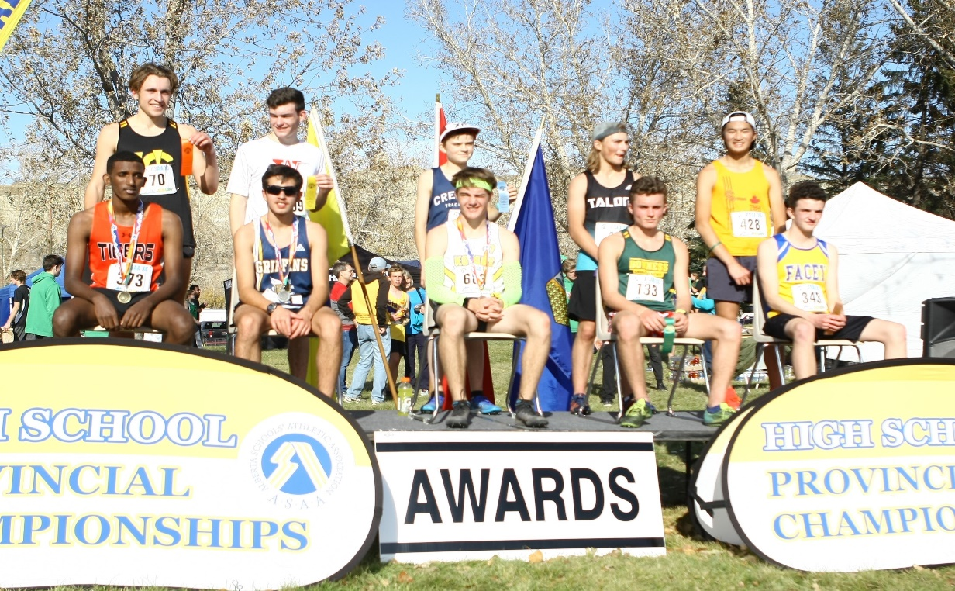
ASAA 2019 Provincial Cross-Country Running Championship TOP 10 Senior Females
Place | Name | School | TIME
1 | EMMA LANGSTROM | HARRY AINLAY | 21:54
2 | ELLA MARION | WESTERN CANADA | 22:13
3 | ISOBEL HENDRY | CANMORE COLLEGIATE | 22:23
4 | FAITH BLANCHETTE | ST. JOE’S CATHOLIBC | 22:39
5 | JENNA SHERRINGTON | BISHOP CARROLL | 22:46
6 | MADISON FORD | LILLIAN OSBORNE | 22:55
7 | CHLOE PALMER | MCNALLY | 23:01
8 | DANA SYCH | HAY LAKES | 23:09
9 | MAKENNA GRAHAM | ARCHBISHOP MACDONALD | 23:11
10 | ELIZABETH VANDERPUT | HENRY WISE WOOD | 23:19

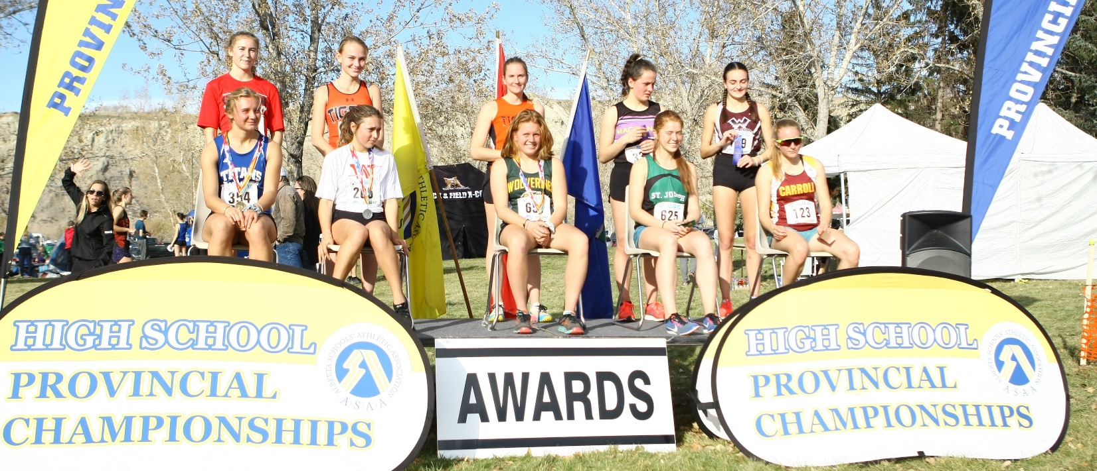
ASAA 2019 Provincial Cross-Country Running Championship TOP 10 Senior Males
Place | Name | School | TIME
1 | KAJELA BURE | JAMES FOWLER | 20:23
2 | BILL MAKWAE | OLD SCONA ACADEMIC | 21:23
3 | JARED HOWSE | ST. JOSEPH (RED DEER) | 21:47
4 | EVAN VAMMEN | SIR WINSTON CHURCHILL | 21:54
5 | HUW MORGAN | BISHOP CARROLL | 21:59
6 | JASON USHKO | STRATHCONA | 22:16
7 | KOBE GROCHOLSKI | BEAVERLODGE REGIONAL | 22:22
8 | OWEN PIMM | LINDSAY THRUBER | 22:34
9 | BROCK JENSEN | CHINOOK | 22:49
10 | MIKA EGGINK | NOTRE DAME | 22:53

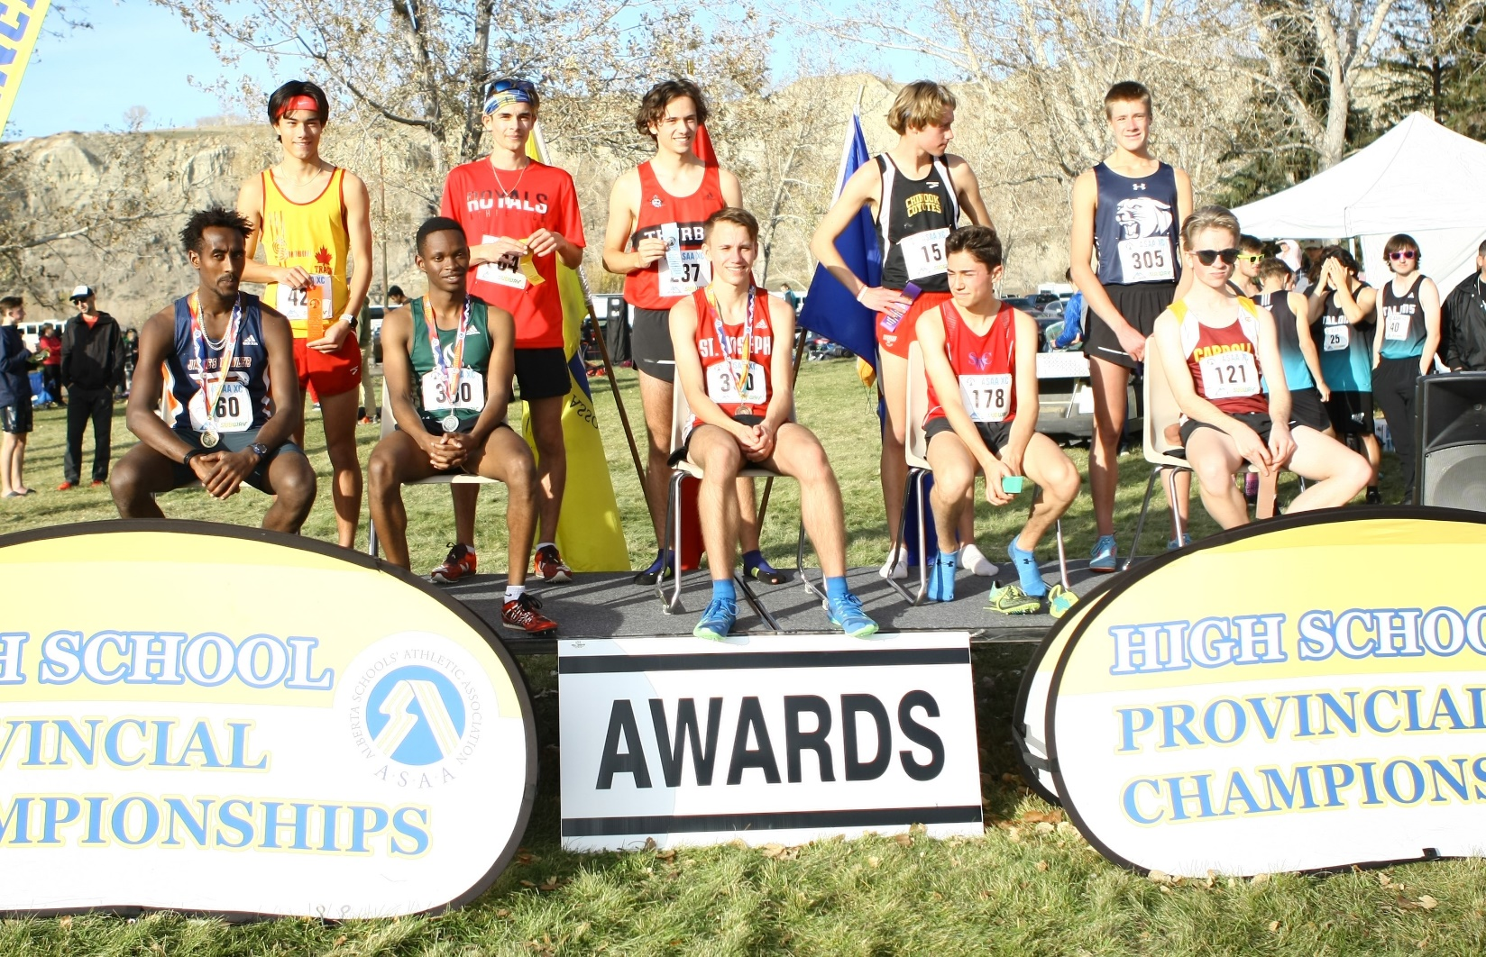
ASAA 2019 Provincial Cross-Country Running Championship TOP 10 PARA Athletes
Place | Name | School | TIME
1 | RILEY VAN VILET | NOBLE CENTRAL | 8:21
2 | KEEGAN KOLODY | MEDICINE HAT HIGH SCHOOL | 9:11
3 | SHAWN LYSONS | ST. PAUL REGIONAL | 9:41
4 | JOSH GRAHAM | EAGLE BUTTE HIGH SCHOOL | 10:16
5 | SAN HENDERSON | MEDICINE HAT HIGH SCHOOL | 14:51
6 | CANNON BEVANS | CARDSTON | 15:06
7 | DARREN SAZLZ | EAGLE BUTTE HIGH SCHOOL | 16:54

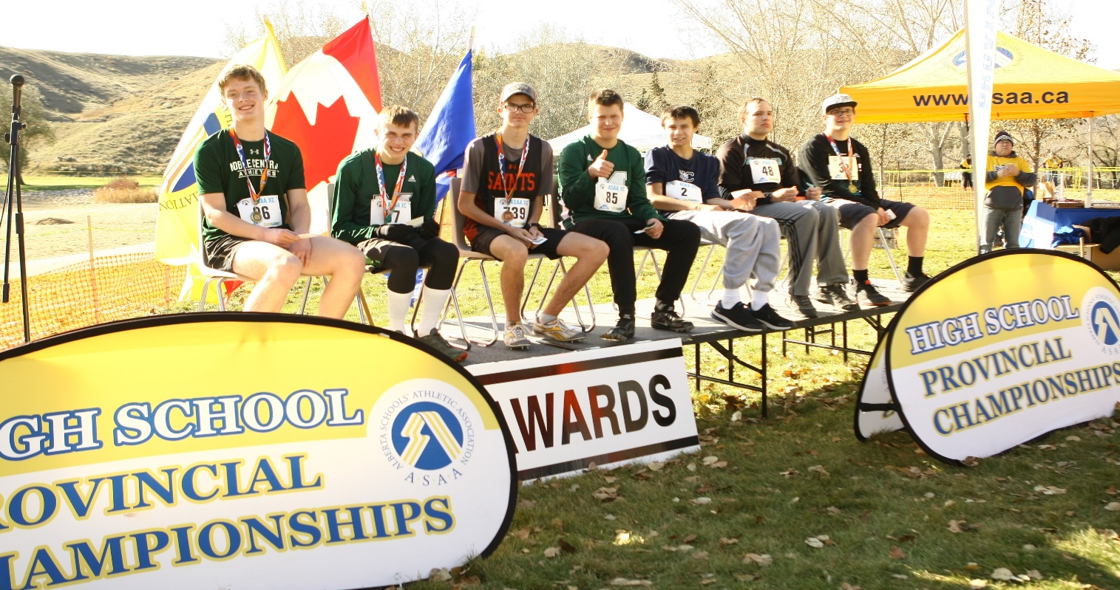

Top 5 School Team results in each category.
1A Schools
Place | School | Points | Zone
1st | Parkland Immanuel Christian | 722.19 | Edmonton
2nd | New Norway | 693.64 | Central
3rd | Bassano | 550.90 | South Central
4th | St. Mary High (Westlock) | 372.74 | North Central
5th | Ecole La Verendrye | 226.18 | South

1A Provincial Champions
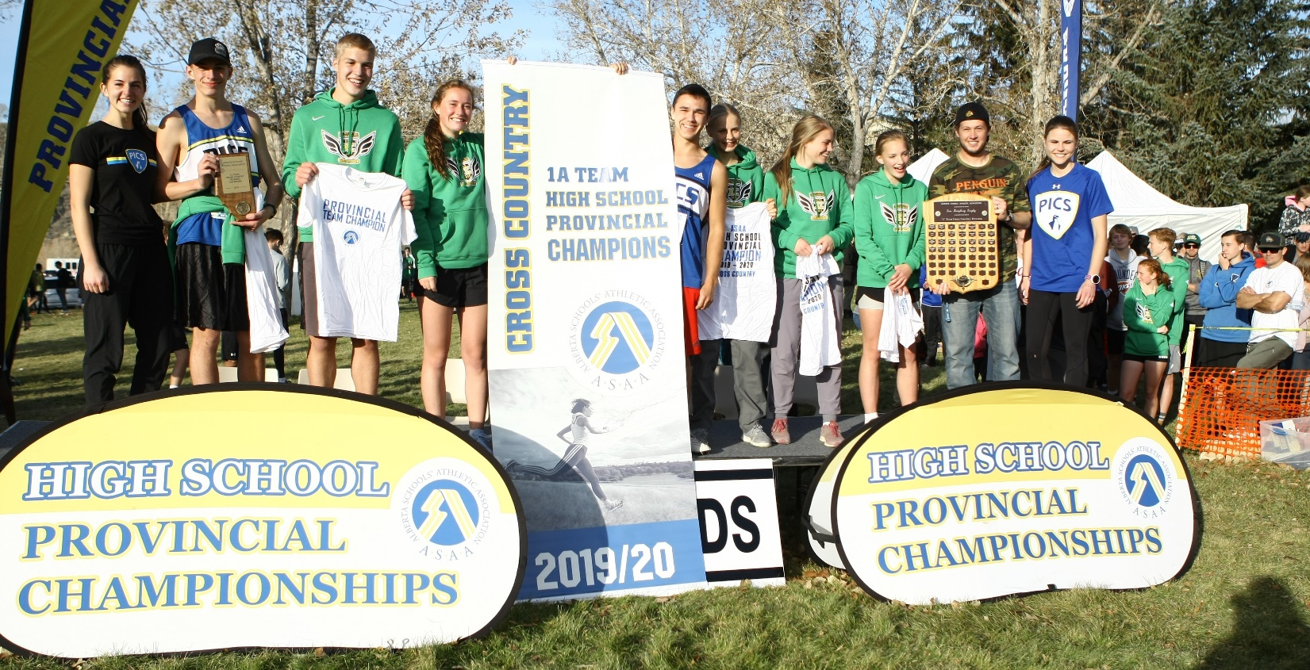
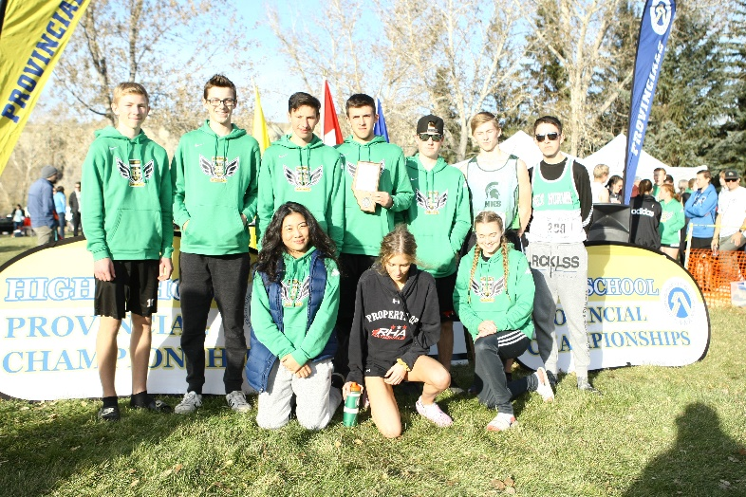
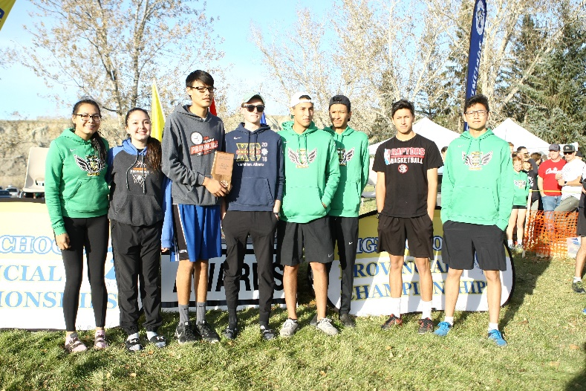
1A 2nd place 1A 3rd place
2A Schools
Place | School | Points | Zone
1st | Raymond | 841.53 | South
2nd | St. Timothy | 760.48 | Calgary
3rd | Strathcona-Tweedsmuir | 745.27 | South Central
4th | JR Robson | 424.29 | North East
5th | Hugh Sutherland School | 384.67 | South Central

2A Provincial Champions
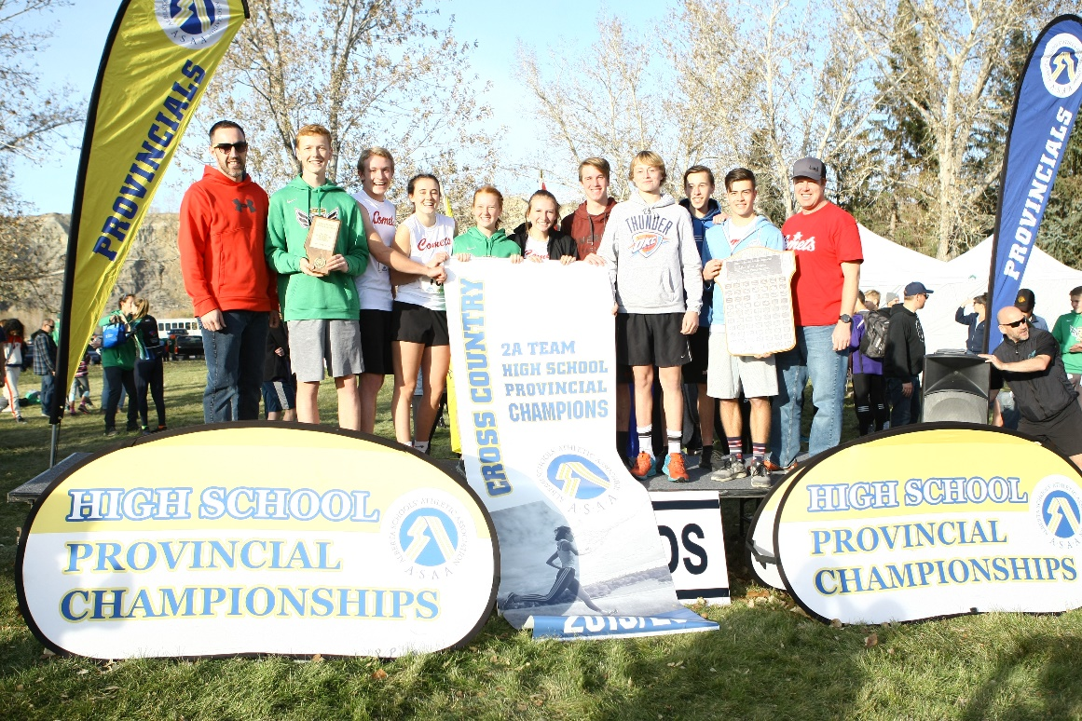
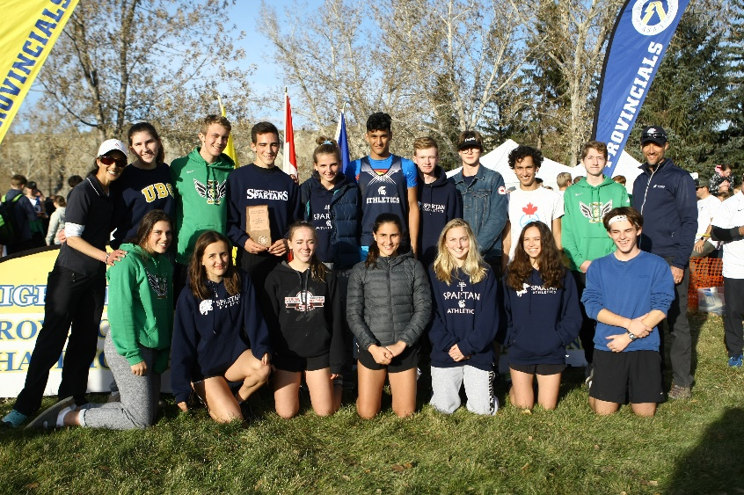
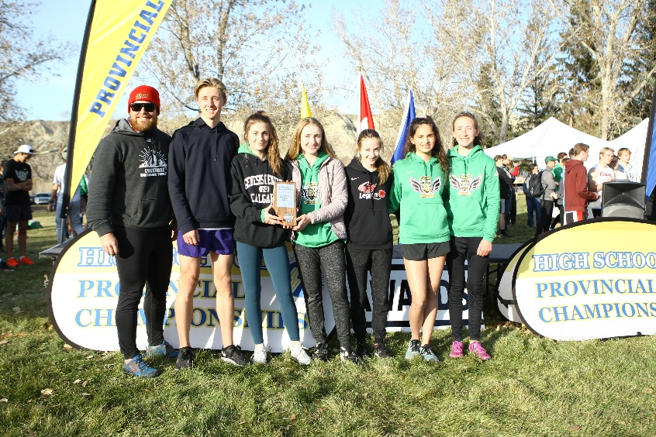
2A 2nd place 2A 3rd place

3A Schools
Place | School | Points | Zone
1st | Lethbridge Collegiate | 1707.99 | South
2nd | Eagle Butte | 1274.31 | South
3rd | Strathmore | 862.30 | South Central
4th | St. Paul Regional | 625.74 | North East
5th | JA Williams | 581.04 | North East

3A Provincial Champions
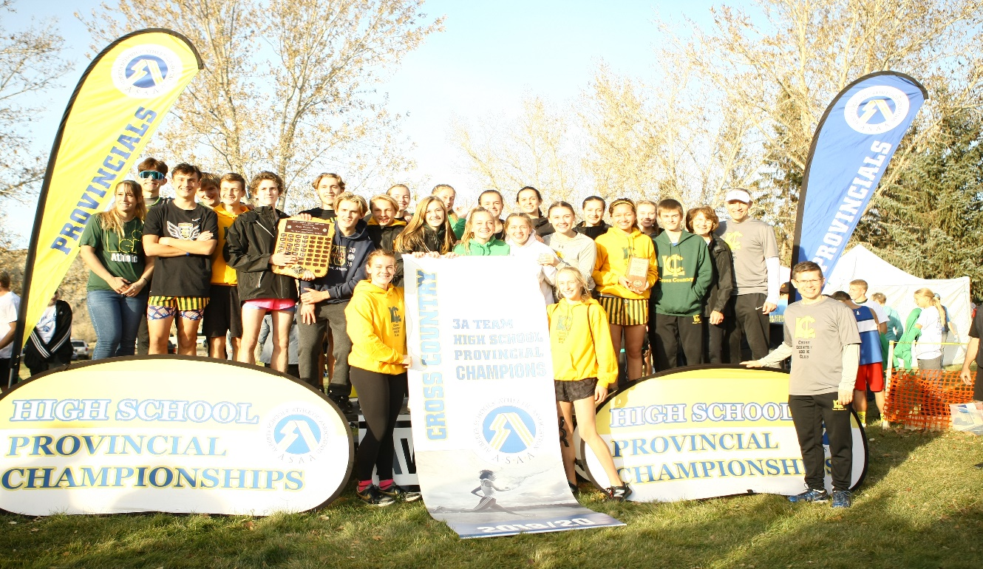
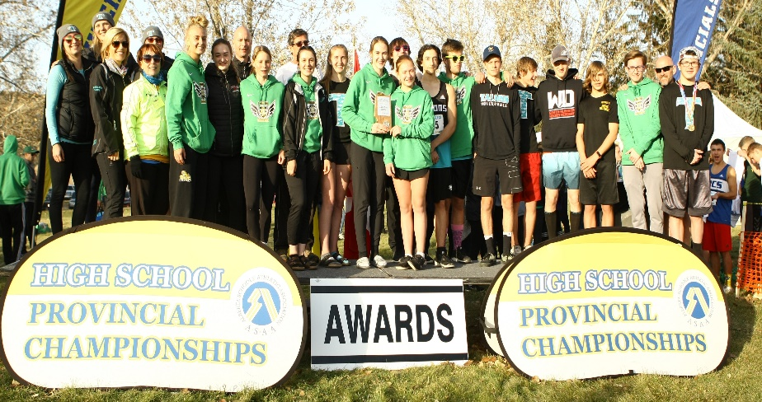
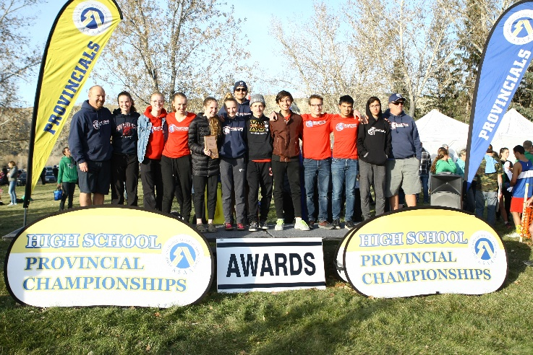
3A 2nd place 3A 3rd place

4A Schools
Place | School | Points | Zone
1st | Strahcona | 2557.44 | Edmonton
2nd | Lindsay Thurber | 1666.61 | Central
3rd | Western Canada | 1562.59 | Calgary
4th | William Aberhart | 1361.83 | Calgary
5th | Harry Ainlay | 1144.85 | Edmonton

4A Provincial Champions
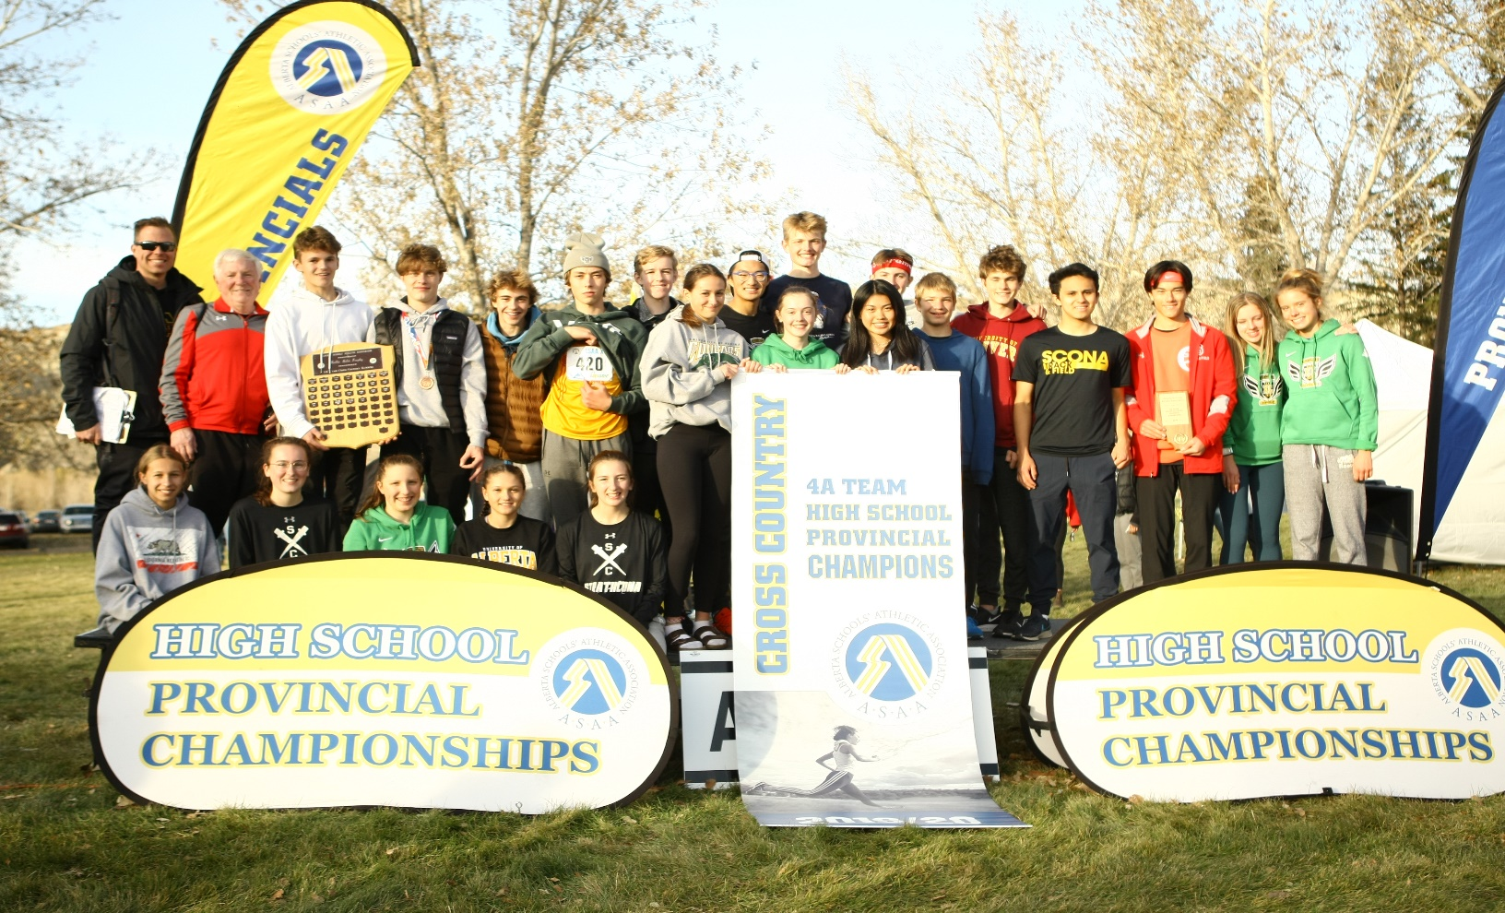
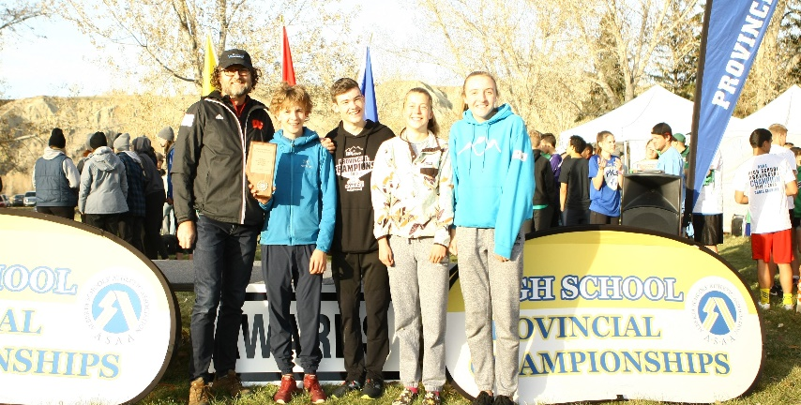
4A 2nd place 4A 3rd place
