Emergency Action Plan Lillian Osborne High School
2019 Leger Road, Edmonton, AB, T6R 0R9

Emergency Phone Numbers: 9-1-1

Cell Phone Number of Athletic Director: 780-231-3759 (Kate Greabeiel)
Cell Phone Number of Administrator: 780-686-6793 (Asst. Principal – Danny Jeffery)

Charge Person: Coach or Team Official with highest level of First Aid

Closest Phone: Physical Education Offices (there is an office attached to each of the gyms)
(780) 391-2450
Cell phone reception within the school is often unavailable.

AED Location: Lobby area outside Large (South) gym on east wall

Call Person: Assistant Coach
Responsibilities:
- Call for emergency help and provide all necessary information to dispatch (e.g. facility location, nature of injury, what, if any, first aid has been done, number you are calling from). 
- If on a cell phone you will need to go outside of gym/building to get reception.
- Clear any traffic from the entrance/access road before ambulance arrives. 
- Wait by the driveway entrance to the facility to direct the ambulance when it arrives. 
- Call the emergency contact person listed on the injured person’s medical profile.
- Coaches should have emergency contact information sheets for all athletes in their med kits or coaches bag. All athletes participating on Osborne teams have parental consent for school to obtain medical care deemed necessary in the event of an injury.

Control Person: Parent or Official/Referee
Responsibilities:
- Control bystanders.
- Allow charge person space to assess/treat injured party.
- Retrieve any equipment need by charge person including AED.

Emergency Access:
- Large (South) gym: EMS to enter through front doors of the school & head to their left directly towards the large gym. Alternate access available through emergency doors on north side of gym. (no road access to these doors)
- Small (North) Gym: EMS to enter through front doors of the school & head to their left directly towards the large gym. There is a hallway on the left-side of main gym entrance which you follow to reach small gym. Alternate access available through emergency doors on west side of gym. (no road access to these doors)
- A person will always be waiting at school’s main doors to direct EMS to necessary location
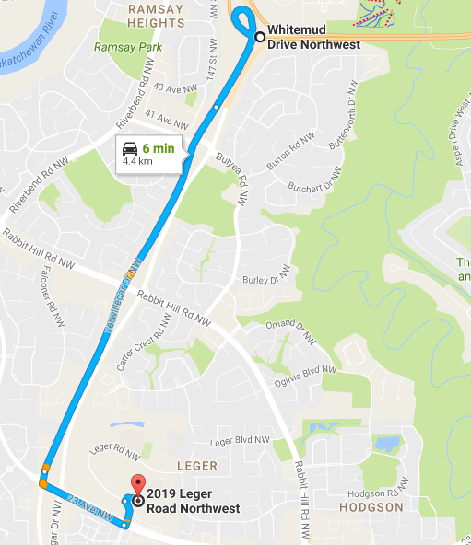
Directions to Lillian Osborne from Whitemud Drive:
- From Whitemud Drive take Terwillegar Drive
exit (south) continue on Terwillegar Drive until
23rd Avenue.
- Turn left on 23rd Avenue going West.
- From 23rd Avenue turn north onto Leger Road
(lights at Leger Transit Station/also signs for
Terwillegar Recreation Center).
- Take first right at pedestrian lights into loop.
- Stay to the right & school’s main entrance will
be immediately on the right-hand side.

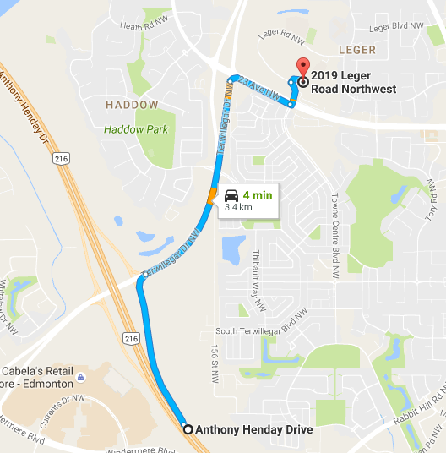
Directions to Lillian Osborne from Anthony Henday Drive going North:
- From Anthony Henday Drive North take
Terwillegar Drive exit and merge right (east) at
the lights.
- Continue on Terwillegar Drive until 23rd Avenue.
- Turn right on 23rd Avenue going West.
- From 23rd Avenue turn north onto Leger Road
(lights at Leger Transit Station/also signs for
Terwillegar Recreation Center).
- Take first right at pedestrian lights into loop.
- Stay to the right & school’s main entrance will be
immediately on the right-hand side.

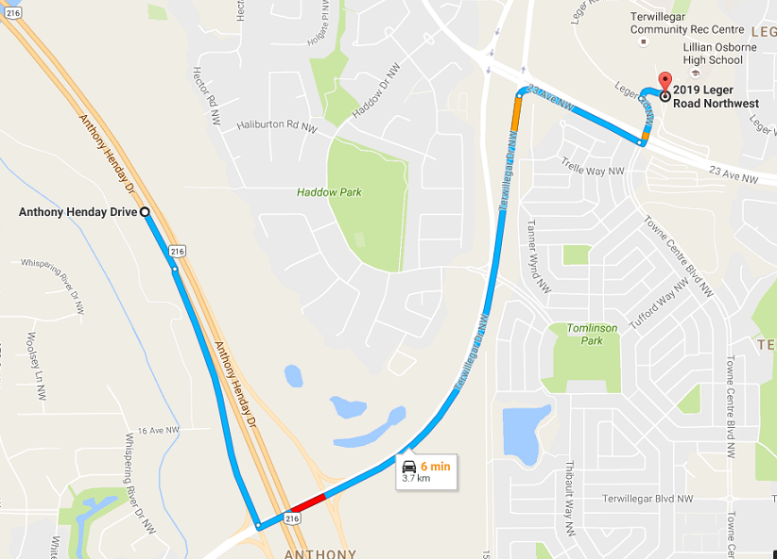
Directions to Lillian Osborne from Anthony Henday Drive going South:
- From Anthony Henday Drive North take
Terwillegar Drive exit and turn left (east) at
the lights.
- Continue on Terwillegar Drive until 23rd Avenue.
- Turn right on 23rd Avenue going West.
- From 23rd Avenue turn north onto Leger Road
(lights at Leger Transit Station/also signs for
Terwillegar Recreation Center).
- Take first right at pedestrian lights into loop.
- Stay to the right & school’s main entrance will be
immediately on the right-hand side.
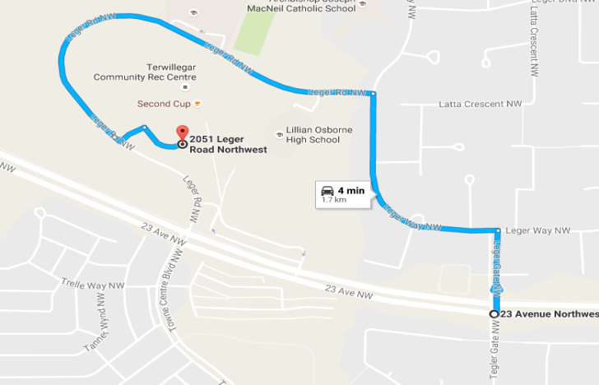
Alternate Access to Lillian Osborne also from 23rd Avenue:
- Turn north onto Leger Gate
- Turn left (west) on Leger Way
- Turn left (west) on Leger Road.
- You can follow road around to the school’s
front entrance or enter into back parking
lot from the north side of the school. Back
parking lot will be available in January 2017

Closest Emergency Rooms:
University of Alberta Hospital (11.4km)
8440-112 Street, Edm, AB, T6G 2B7 Main line 780-407-8822
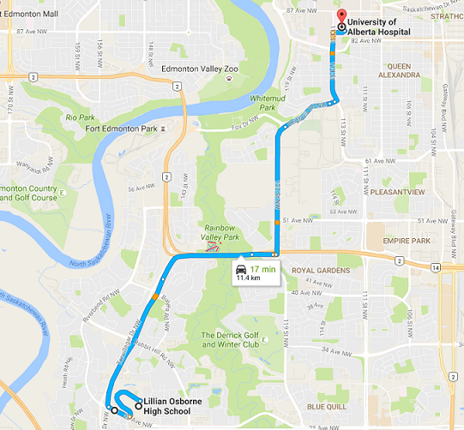

- Follow turnaround out to Leger Road
- Turn left on Leger Road
- Turn Right on 23rd Avenue
- Take exit north onto Terwillegar Drive
- Take exit east onto Whitemud Drive
- Take 122st exit & go north, road turns
into Belgravia Road
- Turn left (north) on 114st
- Follow signs to Emergency Department
Entrance

Grey Nuns Community Hospital
1100 Youville Drive, Edm, AB, T6L 8X8 Main line 780-735-7000
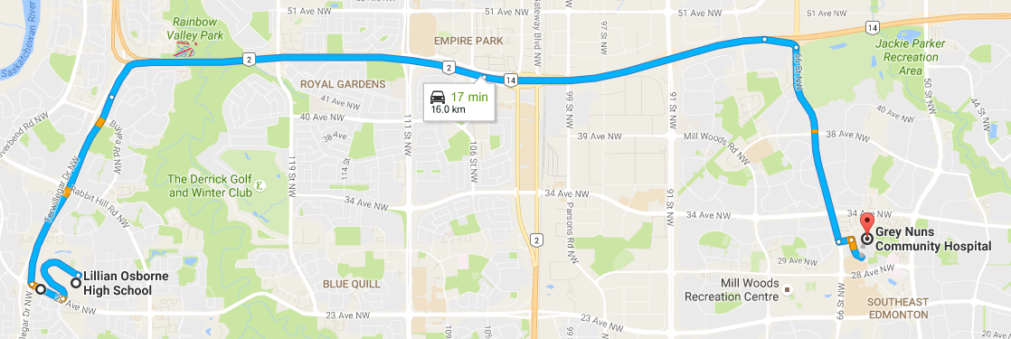
- Follow turnaround out to Leger Road
- Turn left on Leger Road
- Turn right on 23rd Avenue
- Take exit north onto Terwillegar Drive
- Take exit east on Whitemud Drive
- Take 66st exit south
- Turn left (east) on 31st Avenue
- Turn right (south) on Youville Drive
- Follow signs to Emergency Department
Entrance

Closest Medical Clinic:
Terwillegar Medical Clinic (1.3km)
101-121 Haddow Close, Edm, AB, T6R 3W3 Main line 780-989-5300
Hours: Mon-Fri 8:00am-4:30pm

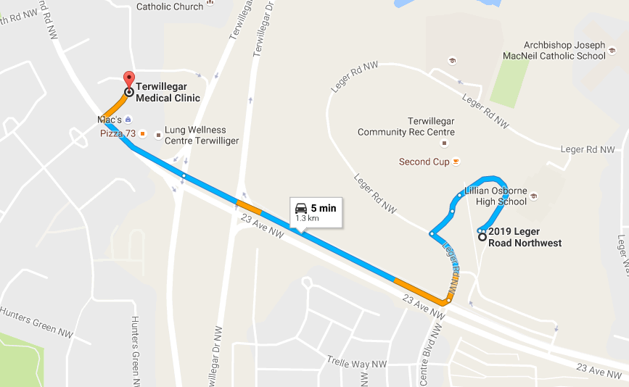
- Follow turnaround out to Leger Road
- Turn left on Leger Road
- Turn right on 23rd Avenue
- Continue on 23rd ave to Haddow Close
- Turn right onto Haddow Close
- Destination will be on the right-hand side

When to Activate Emergency Action Plan
If the participant:
- is not breathing
- does not have a pulse
- is bleeding profusely
- has impaired consciousness
- has injured the back, neck or head
- has visible major trauma to a limb
- cannot move his/her arm or legs or has lost feeling in them
- or if no one with first aid training is available

During an emergency
- All players not direct assisting the charge person should remain at the team’s bench. Team captains can assist in this organization as coaches and assistant coaches are likely involved with the injured athlete

