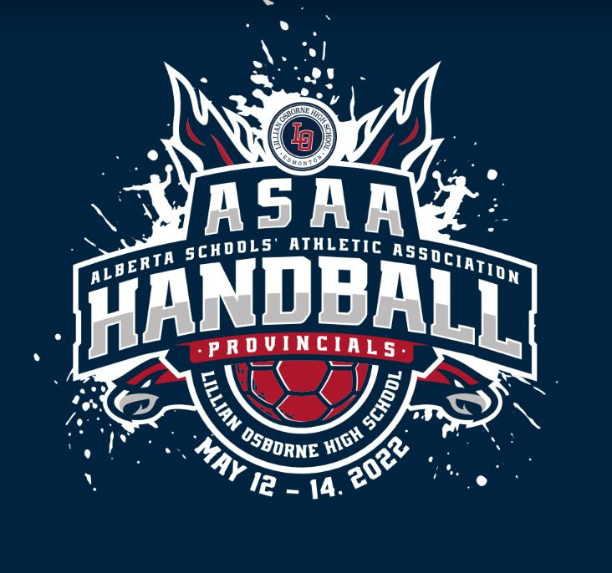

Alberta Schools’ Athletic Association
Team Handball
Tier 1
Provincial Championships

May 12-14, 2022

Proudly Hosted by Lillian Osborne High School

Tournament Chairperson
Kate Greabeiel, Athletic Director, Lillian Osborne High School,
2019 Leger Road, Edmonton, AB T6R 0R9
kate.greabeiel@epsb.ca
Office - (780) 391-2450 ext. 2206 Cell - (780) 231-3759

Tournament Venue
Lillian Osborne High School: 2019 Leger Road, Edmonton, AB
Tournament @ a Glance

Tuesday May 10th
7:45pm Coaches & Captain’s Meeting - Virtual

Thursday May 12th
4:00 pm - Tournament Competition Begins @ Lillian Osborne

Friday May 13th
10AM-9PM Tournament Games @ Lillian Osborne High School

Saturday May 14th
8:00AM-10:30PM Tournament Games @ Lillian Osborne High School
(Awards will follow the completion of each medal game)

Tournament Schedule with specific teams will be available online on Monday May 9th. Hard copies will be distributed to all teams in their welcome packages and will be available at the venue.

Registration & Team Information
** All registration forms must be completed
Online by 12:00 noon on Monday May 9th.**
This deadline will be strictly adhered to.

Registration

Tournament Entry Fee: $350.00
ASAA Loonie Fee: $1 per athlete; goes toward ASAA Pay it Forward Scholarship for Student Athletes

**Please bring a combined cheque of Entry fee & Loonie fee, payable to Lillian Osborne High School with you to your first game.**

Coaches Meeting
The tournament coaches meeting will take place online on Tuesday May 10th at 7:45 PM. Google Meet invitation will be sent out to head coaches based on registration information collected by Monday May 9th @ noon. It is mandatory for one coach or team official per team to attend and you may choose to invite a team captain as well.

As per the ASAA Official Handbook:
“Any team (football, volleyball, basketball, cheerleading, curling, rugby, team handball) that attends provincials as the zone/regional representative and fails to attend or send a team representative to the mandatory coaches meeting will be ﬁned a fee of $250 for failing to send a representative to the coaches meeting. This fee will be collected by the ASAA ofﬁce and split between the host of the championship and the ASAA; the latter of which will be earmarked for the ASAA subsidy account to help offset costs to ASAA provincial hosts. The Executive will have the sole discretion to waive the penalty based on the rationale provided by the school for failure to attend the coaches meeting.”

Official Game Ball
The official game ball will be an Alberta Team Handball Federation approved HUMMEL or MOLTEN Size 3 (Boys) and Size 2 (Girls).
Practice Balls
Participating teams are required to bring their own handballs for warm-ups. Please do not use handballs in hallways or change rooms.
Change Facilities
Athletes will have access to shared change rooms before and after matches. Please keep all valuables with you, as these rooms will not be secured. Athletes must change in the change rooms.

Team Uniforms
All teams must have at least one set of matching team uniforms. Goalies must wear a contrasting colour. Host schools will have pinnies available in the event that two teams are wearing the same colour. Teams listed first on the schedule will be considered the home team and would be required to change uniforms or wear the pinnies.

Tournament Admission
Friday/Saturday Single Day Admission -- Adult - $8 Student/Senior - $5

Adult Tournament Pass - $15 Student/Senior Tournament Pass - $10
Children 12 and Under – Free when accompanied by an adult.

Osborne Students will have free admission with VALID/CURRENT STUDENT ID.

Programs will be available online.

The ushers will be available to direct spectators across the court when breaks in play allow for passage.

Fair Play & Sportsmanship
All competitions must be conducted with a high standard of courtesy, fair play and sportsmanship. All those involved share this responsibility.

Coaches
The coaches must demonstrate qualities of courtesy and good sportsmanship. These are evidenced by proper acceptance of officials’ judgment, positive encouragement of player performance and bench behaviour.

Athletes
Athletes must demonstrate qualities of courtesy and good sportsmanship by proper acceptance of officials’ judgment and by showing proper respect for opposing athletes as well as for teammates.

Spectators
A. Spectators, both student and adult, must demonstrate courtesy and good sportsmanship by positive cheers of encouragement for their team, not against the opposing team. This is evidenced by the absence of booing and vulgarities. Spectators must also show proper acceptance of officials’ judgment. Artificial noisemakers are not permitted during provincial championship tournaments/events. These noisemakers may include but are not limited to: air horns, cow bells, plastic tube horns, garbage can lids, etc. The provincial championship host shall have the authority to eject from the competition facility individuals who, following a warning, refuse to comply with this re requirement.

B. Eviction for Inappropriate Language and/or Behaviour -The Executive Committee or its host/designated representative shall have authority to direct any person to immediately leave any premises or venue hosting any ASAA sanctioned event if that person:
1. exhibits rude or abusive behaviour to any other person
2. uses vulgar, obscene or abusive language and/or gestures
3. fails to promptly follow any reasonable direction given to that person by the designated ASAA representative

The Executive Committee or its designated representative shall have the authority to notify local law enforcement personnel of the failure of any person to immediately comply with a direction to leave any premises or venue hosting any ASAA sanctioned event.

ASAA Code of Ethics
All athletes, coaches and spectators are expected to abide by the ASAA code of ethics. Information regarding the ASAA’s code of ethics can be found on Pages 27-34 of their 2021/22 ASAA Official Handbook.
Sportsmanship Awards
Every ASAA Provincial Championship will receive 5 sportsmanship pins to distribute to individuals during the event. There will also be a team Sportsmanship award presented. The Sportsmanship committee (Murray Smith, Bryan Klaus, Chris Jones & David Brimacombe) will be responsible for selecting recipients of the ASAA’s sportsmanship pins and the team award.

Sportsmanship is vitally important and highly valued by the ASAA. A Sportsmanship plaque will be awarded to the team that displays appropriate conduct & sportsmanship both individually and at a team level throughout the Championship. Pins will be handed out throughout the Championship to individuals & spectators who display sportsmanship in their words & actions. The sportsmanship committee will be deciding who receives these awards.

Results
Teams may request a copy of game sheets following their games. Following each game, the scores will be updated on the website and on the draw board posted just outside of the gym.

Parking
During the school day (until 4:00) on Thursday & Friday parking will be difficult because regular school is in session. Teams/fans will have to find parking on the street behind the school & in the SOUTH lot of the Terwillegar Recreation Center. Please DO NOT park in the staff/student lot prior to 4:00 on Thurs & Fri. Violators may be ticketed. After school hours on Thurs, Fri & all day Saturday parking will be available in the staff/student lots on the south side of the school.

Minor Officials
Minor officials will consist of a collection of students from the school. Please treat these individuals with respect and dignity at all times, as they are volunteers.

Grievance/Discipline Committee
A small 3 person grievance committee will exist in the event a team wishes to file a grievance. It will consist of 1) Murray Smith – Dept Head/Physical Education Teacher, Lillian Osborne High School 2) Head Official at the Event from ATHF 3) ASAA representative.

There are 2 key functions of the Grievance/Discipline Committee at ASAA provincials. The First function is to deal with matters that occur during competition, typical discipline/conduct issues, and appeals that may arise from ejections. The Second function is to handle any other matters that arise that require dispute resolution. Please refer to the Grievance/Discipline section of the provincials host handbook for more information.

Clothing
Tournament logoed clothing will be provided by Elite and will be available online by completing the team order form. Individual orders will not be accepted. Ordered will be sent directly to schools following the event.

Accommodations
The City of Edmonton has many affordable hotels available depending on the amenities that your team is looking for. There are many hotels available in South or West Edmonton all of which are close to Osborne via Whitemud & Anthony Henday Freeways.

Venue Rules
Please remind athletes & spectators that during games on Thursday & Friday, they should not be wandering through the halls of the school as regular classes will be in session.

**Lillian Osborne High School is not responsible for any lost or stolen items. Please inform your teams to take care of their personal belongings.**
First Aid
First aid/Athletic Therapy will NOT be available at the gym during tournament play. Teams must provide their own med kits, supplies and personnel. Ice will be available upon request for injuries. Ice machine is accessible in the Phys. Ed office which will also act as the coaches/officials room.

The University of Alberta, Grey Nuns & Misericordia hospitals are all a similar distance away from Lillian Osborne. In the event of an emergency, please dial 911 for access to Edmonton Paramedics.

Emergency Action Plan
The emergency action plan for Lillian Osborne’s Gym(s) is available on the tournament website and hard copies will be included in all coaches information packages. These procedures will also be discussed at the pre-tournament coaches meeting.

