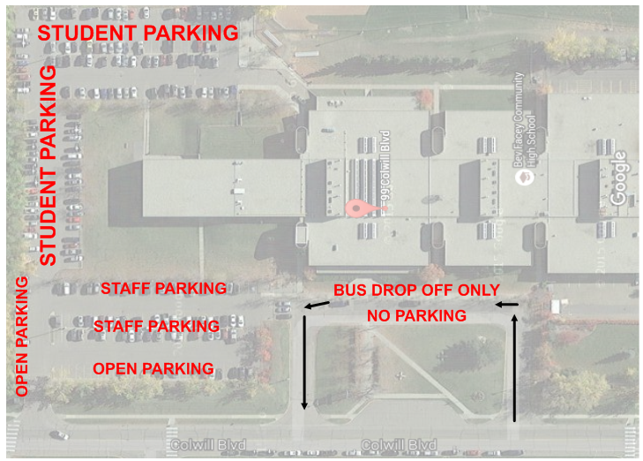

- RESTRICTED/LIMITED PARKING ON FRIDAY (PLEASE USE OPEN PARKING AREA ONLY ON FRIDAY UNTIL 2:00 PM). OPEN PARKING ON SATURDAY IN STAFF AND STUDENT PARKING ZONE.
- OPEN PARKING AVAILABLE ON FRIDAY AND SATURDAY IN STRATHCONA ATHLETIC PARK (ON CLOVERBAR ROAD)
- THE LOOP IN FRONT OF THE SCHOOL IS FOR EMERGENCY ACCESS AND DROP OFF ONLY. NO PARKING!

