

2A Girls Provincial Basketball Championships
March 17-19, 2016
Picture Butte High school
Picture Butte, Alberta

INFORMATION PACKAGE

LOCATION:
Picture Butte High School

401 Rogers Avenue
Picture Butte, Alberta
Main Phone: (403)-732-4404
Email: jon.vandegriend@prs26.ca
Website: www.asaa.ca

TOURNAMENT CHAIRS:
Jon Vande Griend Mark Lowe
(W) (403) 732-4404 (W) (403) 732-4404
(C) (403) 894-8454 (C) (403) 915-6982
jon.vandegriend@prs26.ca mark.lowe@prs26.ca

RESPONSIBILITIES:
Program & Admissions | Crystal Stauth and Mark Lowe
Website | Aaron Skretting and Justin Clark
Concession Stand | Sheryl Loman and Jackie Elaschuk
Coach/Officials Room | Sheryl Loman and Jackie Elaschuk
Minor Officials/Referees | Jon Vande Griend
Finances/Fees | Mark Lowe and Cherie Secrist
Media | Mark Lowe
Photography | Tony Kok Photography and Mark Lowe’s Media Group
Banquet | Cherie Secrist and Joanna Johnson
Score Table Supervisor | Jon Vande Griend and PBHS staff

GRIEVANCE COMMITTEE
Jon Vande Griend, Mark Lowe, Aaron Skretting, Two Neutral Coaches, Head Official

The committee will have the authority to address issues of a serious nature that may occur before, during or after the provincial championships, or to hear appeals of the automatic suspension resulting from an ejection. All grievance issues will also be brought to the attention of ASAA before decision is reached or handed down.

RULES/POLICY:
It is incumbent upon all coaches and participants to be aware of ASAA Policy. Specifically for this event, player eligibility (pp 37-44), supervision policy (pg 51-52), and basketball policy (pp 81-91).

DISCIPLINE AND MISCONDUCT:
Breaches of the ASAA Code of Ethics are treated seriously, and as host, [we] are required to report any breaches to the ASAA office where action may occur. A portion of the ASAA Code of Ethics states, “Any conduct, including, but not limited to ejections, fighting and drugs and alcohol use, that results in dishonor to the athlete, the team, the school or the ASAA will not be tolerated.” (pp 27)

SPORTSMANSHIP:
Sportsmanship is vitally important and highly valued by the ASAA. A Sportsmanship plaque and banner will be awarded to the team that displays appropriate conduct & sportsmanship both individually and at a team level throughout the Championship. Pins will be handed out throughout the Championship to individuals & spectators who display sportsmanship in their words & actions. The sportsmanship committee will be deciding who receives these awards.

SPORTSMANSHIP COMMITTEE
Aaron Skretting, Deanna Ward, Jon Vande Griend, Brian Elaschuk, Malinda Bergen-Henengouwen, Arnie Bergen-Henengouwen

Throughout the tournament, players, parents, staff and spectators can be nominated or brought to the committee for outstanding acts of sportsmanship. Those individuals will then receive recognition on behalf of the ASAA and the committee for the event.

ACCOMMODATIONS:
Rooms have been booked for the tourney at The Lethbridge Lodge Hotel.
All teams will be guaranteed 7 rooms for players and coaching staff, etc. All rooms (up to 4 occupants) will receive complimentary Hot Breakfast Buffet and will receive coupons upon check in. Rooms are $125 + taxes.

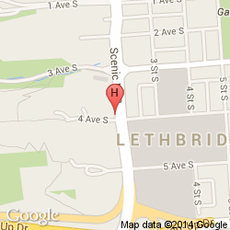
Any families wishing to book extra rooms not included within the 7 allotted, should do so on their own. The deadline to confirm rooms is Monday, March 14 at 12:00pm. All unused rooms will be released after that time.

The Lethbridge Lodge Hotel (www.lethbridgelodge.com)
320 Scenic Drive Lethbridge
(403)328-1123
Toll free: 1-888-423-0962

Directions:
From North- take HWY #2, turn onto HWY#3, cross river, take both “Via City Centre” exits, at the lights turn Right. Hotel is 2 blocks south on the right hand side.

From East- stay in the right hand lane on HWY#3, take exit labeled “Scenic Drive South”, turn left. Hotel is 4 blocks south on the right hand side.

TOURNAMENT AT A GLANCE:

Registration Deadline 12:00 Noon on Monday, March 14, 2016
Banquet Ticket Deadline 12:00 Noon on Monday, March 14, 2016
Program Pictures & Data Deadline 12:00 Noon on Monday, March 14, 2016
Practice Times & Pictures 2:30 PM – 10:00 PM on Wed., March 16 2016
Team Pictures ½ Hour Before Scheduled Practice Time
Coaches Meeting 8:30 AM on Thursday, March 17, 2016
Opening Ceremonies 9:15 AM on Thursday, March 17, 2016
Banquet 7:00 PM on Thursday, March 17, 2016
Provincials Game Schedule 11:00 AM – 4:15 PM Thursday, March 17, 2016
9:00 AM – 9:15 PM Friday, March 18, 2016
9:00 AM – 7:30 PM Saturday, March 19, 2016

REGISTRATION DEADLINE:
Registration will occur online: http://provincials.asaa.ca under the registration link. The online forms include a Team Roster, Team Picture (minimum 3 megapixel picture with optical zoom) and Team History. Please send your team logo to jon.vandegriend@prs26.ca as soon as possible in a jpeg format. Banquet Tickets are also available online. Deadline for Registration is Monday, March 14th @ 12:00 noon.

REGISTRATION & BANQUET FEES:
Entry Fee: $460 per team
Banquet Fee: $25 per person 15 tickets per team max.
ASAA “Pay it Forward” Loonie Fee: $1 Per Athlete

Please bring one check payable to PBHS.

All official team members will receive a player’s package, souvenir ID participant passes and lanyards. A receipt for the tournament fees will be given in the coaches packages.

BANQUET: $25.00/person
Banquet tickets must be ordered online on the Team Order Form by 12:00 noon Monday, March 14. The attire will be semi-formal. The banquet will be held at the Lethbridge Lodge Expect great food, entertainment and prizes!
THEME: THE ROYAL ROUNDUP

DATE & TIME: Thursday March 17, 2016 @ 7:30PM
DOORS OPEN AT 7:00
LOCATION: 320 Scenic Drive Lethbridge
(403)328-1123
Toll free: 1-888-423-0962

PURCHASING TEAM PICTURES, ACTION PHOTOGRAPHS AND VIDEO:
Team pictures will be taken ½ hour before your scheduled practice time. Pictures will be done in the Drama room attached to the Gathering Area. Individual player pictures and coaching staff badges will also be done at this time. Teams should come dressed in their uniforms or warm up gear.

We have a professional photographer shooting all of the games of the tournament.

Action shots will be taken throughout the tournament and will be available for sale. The location and price will be determined as we get closer to the event.

Video will be taken of all games throughout the tournament and will be available for sale. A professional production company called FeatureProductions.ca will be producing the live stream for us and will do their best to capture all moments in a quality fashion. A link for the live streaming will be linked on the host website.

WEBSITE:
The host website will be kept up to date throughout the tourney. On the site you will find the draw, team biographies, photos, results, LIVE STREAMING and much more. http://provincials.asaa.ca. Please inform your parents about the live streaming that is available.

RESULTS:
All game score sheets will be posted in the hallway of the Gathering Area, as well as on the website immediately following the game. The end result of each game will also be posted on our twitter account: @pbhsathletics

PRACTICE/WARM UP BALLS:
Picture Butte High School will provide all basketballs for use at the event. This includes balls for practice as well as warm-ups. Please do NOT bring your own balls to the school. All basketballs must remain in the gymnasium at all times. We also ask that spectators stay off of the floor during half time to keep the surface clean and safe.

PRACTICE TIMES:
Practice times will be available on Tuesday from 5:00-8:00 for South Zone teams. All other teams will have slots available for practice on Wednesday from 2:30PM – 9:15PM. Each team will be allowed one 45 min. time slot. Practice times are assigned with teams traveling longest distances getting the evening slots. A Schedule of the available practice spots will be sent once teams have registered.

PRACTICE TIMES:
These times will be adjusted once we know where the wild card teams are from.
TIME | MAIN COURT | TIME | MAIN COURT
Tuesday  5:00 – 6:00 | South Zone | Wednesday  4:45 – 5:30 PM | Edmonton Zone
Tuesday  6:00 – 7:00 | South Zone | Wednesday  5:30 – 6:15 PM | Edmonton Zone
Tuesday  7:00 – 8:00 | South Zone | Wednesday  6:15 – 7:00 PM | North Central Zone
Wednesday  2:30 – 3:15 PM | Calgary Zone | Wednesday  7:00 – 7:45 PM | South Central Zone
Wednesday  3:15 – 4:00 PM | Calgary Zone | Wednesday  7:45 – 8:30 PM | North East Zone
Wednesday  4:00 – 4:45 PM | Central Zone | Wednesday  8:30 – 9:15 PM | North West Zone

MEDICAL:
Teams must bring their own medical supplies. Ice will be provided. Amanda Kopjar, Registered Athletic Therapist from the Warner Hockey School will be on site all weekend to Help with any injury management, or taping and strapping.

CHANGE ROOMS/SHOWER FACILITIES:
Shower facilities and change rooms will be available for use at the gym. No valuables should be left in the change rooms. Each team will be given a change room to meet in at half time. Please note: Picture Butte High School is not responsible for lost or stolen articles. Please take your valuables with you after you are done changing.

COACHES/CAPTAINS MEETING:
There will be a coaches meeting at 8:30 AM on Thursday, March 17^{th,} in the PBHS Library, next to the gym. It is mandatory for at least one Coach and Captain from each team to attend this meeting.

The entry fee, banquet fee, and Loonie Fee must be brought to
the coaches meeting in one check.

SCHEDULE/DRAW:
See attached, Appendix A for the schedule as approved by the ASAA.
Please note that the highest ranked team will be designated as the Home team and should wear light uniforms. PBHS will always be designated as the home team during the tournament.

OPENING CEREMONIES/CLOSING CEREMONIES:
The Opening Ceremonies will take place on Thursday, March 17th @ 9:15 AM in the PBHS gymnasium. Please assemble your team in the gathering space next to the gymnasium by 9:00 AM so we can organize the teams. Please have your athletes come dressed in their uniforms or team apparel.

AWARD/MEDAL PRESENTATIONS:
The consolation plaque, fourth place plaque, third place plaque and bronze medals will be handed out after those games are played. This will allow teams to start heading home if needed. Closing Ceremonies and silver / gold medal presentations will take place after the Championship Game.

COACHES & OFFICIALS ROOM:
A hospitality room will be available for coaches and officials throughout the tournament. A variety of food & beverages will be available. The hospitality room will be located next to the gymnasium in the Picture Butte Library and will be open throughout the tournament.

CONCESSION:
An amazing concession will be available Thursday, Friday and Saturday. The concession can be found between the Gathering Area and the Gymnasium.

SPECTATOR ADMISSION/PROGRAM:
Spectators will be required to pay a daily admission. Each day a different colored wrist band will be given and will be non-transferable. Please note that we will not honor wristbands from other Provincial venues and tournaments in the area. A digital copy of the Program will be available on the host website and copies will be available for sale at the event at the gate.

Day Pass Thursday (includes Opening Ceremonies): Friday & Saturday Passes (each day):

Adult: $6.00 Adult: $10.00
Seniors/Students: $4.00 Seniors/Students: $6.00
Children under 12: Free Children under 12: Free
PROGRAMS: AVAILABLE FOR SALE – LIMITED QUANTITY

PARKING:
There are parking lots in front and behind Picture Butte High School. There is also street parking which is accessible. All buses should be parked on the fence line near the baseball diamonds.

MAPS/DIRECTIONS:
See attached map on Appendix B for Map of Lethbridge Lodge Hotel & town of Picture Butte

EMERGENCY ACTION PLAN:
Our facility has Emergency Exit routes in the unlikely event of a fire or other emergency. Only front entrances will be open for entry into the building(s). Our gymnasium has emergency exit doors which will be utilized if necessary. Upon exiting the building, all coaches are responsible to ensure their team members are kept in a group and need to report any athletes unaccounted for to a member of the organizing committee. Further instructions in emergency situations will be dealt with as instructed by the Picture Butte Emergency Services personnel. See Appendix C for more details.

GIMMICS
Gimmics will be providing the souvenir clothing for the Provincial Championships. They will be bringing a variety of clothing styles (eg short and long sleeved t-shirts, baseball shirts, hoodies, sweatpants, and more) with prices ranging from $25 - $50. All prices will include one tournament logo along with GST. To personalize an item with letters/numbers there are additional costs. Payment can be made with cash or through a debit machine.

Appendix A – Draw (*game times may change to accommodate host school)
2A Provincials GIRLS Basketball Draw @ PBHS

A POOL
#8 |  |  |  |  |  | 
Game # 1
11:00 Thursday |  | Game # 6
#9 |  | 10:45 am, Friday
 |  | #1 |  | Game # 11
#5 |  |  |  | 7:30 pm, Friday | Semi-Final
Game # 2
12:45 pm Thursday |  | Game #5
#12 |  | 9:00 am, Friday
 |  | #4 |  |  |  | Championship
#7 |  |  |  |  | Game # 19
Game #3 |  |  |  |  | 7:30 pm, Saturday
2:30 pm Thursday |  | Game # 7
#10 |  | 12:30pm Friday
 |  | #2 |  | Game # 12
#6 |  |  |  | 9:15 pm, Friday
Game #4 |  |  |  |  | Semi-Final
4:15 pm Thursday |  | Game #8
#11 |  | 2:15 pm Friday
 |  | #3
 |  |  |  |  | Loser #11
 |  |  |  |  | Game # 18 | 3rd/4th
C POOL |  |  |  |  | 5:45 pm, Saturday
Loser Game #4 |  |  |  |  | Loser #12
Game #9
4:00 pm, Friday
Loser Game #2 |  | Game # 16 |  | 9th/10th
 |  | 2:15 pm, Saturday
Loser Game #3
Game #10
5:45 pm, Friday
Loser Game #1 |  |  |  | B POOL
 |  |  |  | Loser#5
Loser # 9 |  |  |  | Game #13
Game #15 |  | 11th/12th |  | 9:00 am, Saturday
12:30 pm, Saturday |  |  |  | Loser #6 | Game #17 | Consolation
Loser #10 |  |  |  |  | 4:00 pm, Saturday
 |  |  |  | Loser #7
 |  |  |  | Game #14
 |  |  |  | 10:45 am, Saturday
 |  |  |  | Loser #8

Appendix B – Maps


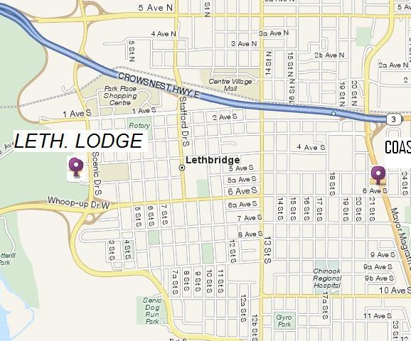

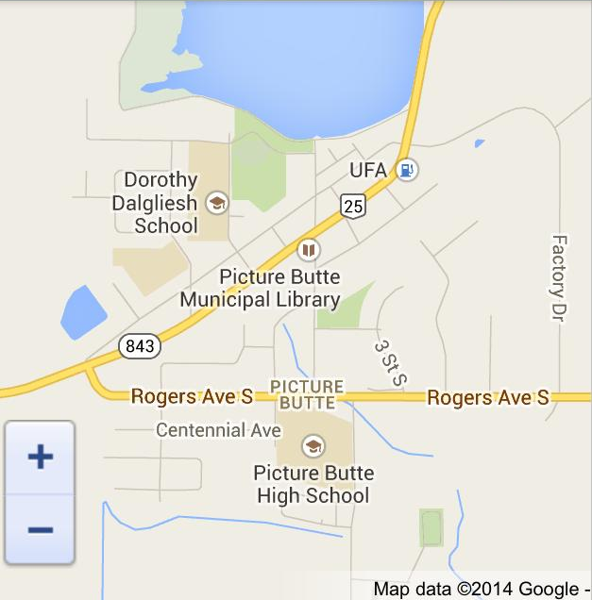

Appendix C – Emergency Action Plan

EMERGENCY ACTION PLAN (EAP)

Please follow and respect the policies and procedures of this Emergency Action Plan (EAP)

While Picture Butte High School does everything possible to prevent injuries and accidents at the school, there is still potential for serious accident and injury in any athletic event. If a serious injury occurs, time becomes critical. Subsequently, the implementation of this EAP must be adhered to while in attendance at Picture Butte High School events.

Person in Charge:
- Administrator in Charge – Mark Lowe or Aaron Skretting
- Tournament Chair – Jon Vande Griend and Mark Lowe
- Teacher Supervisors – Jared Nieboer, Tanya Conrad, Mark Ogle, Jackie Joyal, Stephanie Mills, Mike Oliver, Kate Barwegen, Aaron Skretting, Jeremy Thompson, Natalie Townshend, Jon Vandegriend, Justin Clark
- Custodian - Ragean Jones

First person on scene of accident:
- Assess injury status of a player (particularly head and/or spinal injuries).
- Contact Person in Charge as soon as possible.
- If an ambulance and paramedics are required the Person in Charge will call 911 if he/she deems it necessary and it hasn’t been done yet.
- Person in Charge will take control of an emergency situation until a medical authority arrives.
- Document the events of the accident and file a written report if necessary.

Calling Person in Charge:
- Call Person in Charge (Administrator or Teacher supervisor or Teacher at score table) is responsible for making the 911 telephone call. Teacher supervisors and Teacher at score table are required to have a cell phone on their person while attending an athletic event while at Picture Butte High School.
- Stay in constant communication with the medical provider and the Person in Charge.
- Contact Tournament Chair. Tournament Chair is responsible for having his/her cell phone number available to the call Person in Charge.
- Assist the Person in Charge with the filing of Accident Report if requested.

Control Person:
- The Teacher supervisor and/or other Teachers at the score table are responsible for controlling the crowd and other participants.
- After the area is secured and controlled, the Teacher supervisor will act as the guide for emergency personnel outside of the building to ensure expedient access to the victim.
- Seek highly trained medical personnel in the building if the Person in Charge believes the injury is serious and cannot wait for emergency assistance to arrive.
- In consultation with the Person in Charge, Tournament Chair (if necessary) and game Officials the continuation of play will be determined.

Piyami Health Centre
301A Rogers Avenue
Picture Butte, Alberta
Urgent Care: 403 732 4650
Main: 403 732 4762

Lethbridge Regional Hospital
960 – 19th Street, South
Lethbridge, Alberta
Main: 403 388 6111

Picture Butte is a 911 Emergency Zone

