Making Head Way – Access Guide for ASAA Members
Here are the steps to access Making Head Way:
1. Go to coach.ca
This will take you to the CAC page.
2. Click “The Locker” at the top right of the page
This will take you to the Login page (the red button highlighted in yellow below).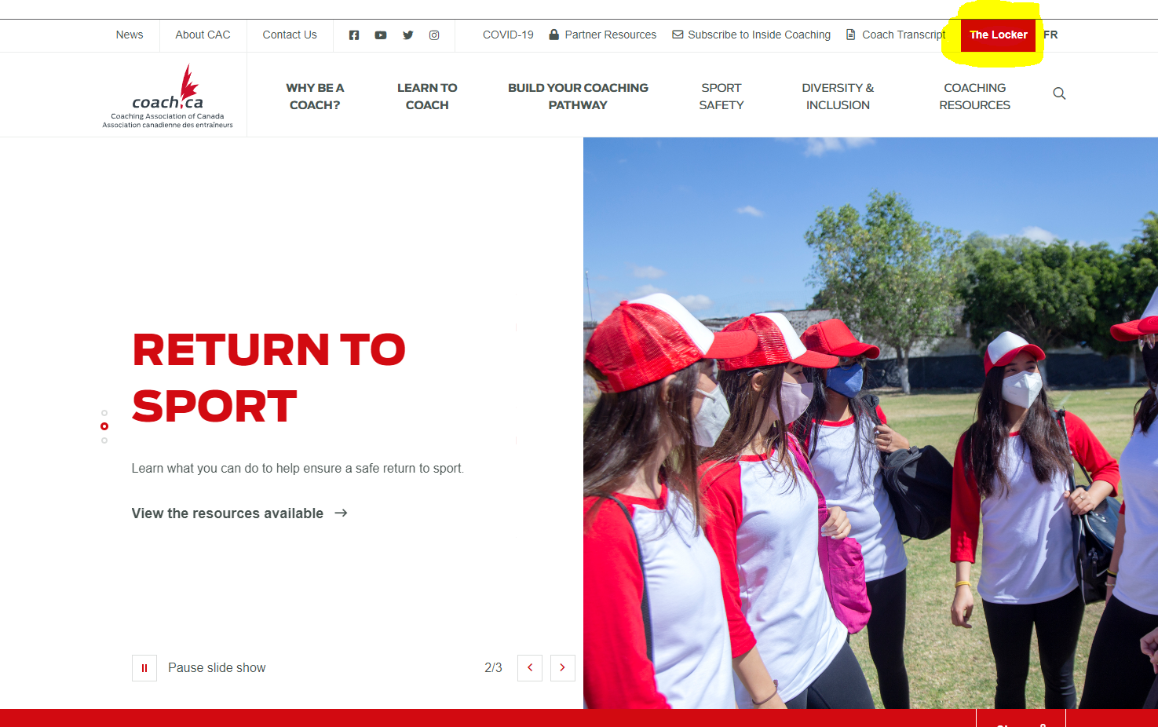
3. You will need to sign in using your NCCP number.
a. If you do NOT have an NCCP number, you can create one by clicking “Don’t have an NCCP #? Create one now!”. Complete the online form.
b. If you do not know whether or not you have an NCCP number, there are a variety of online tools available to assist you including:
i. Look up my NCCP # An email will be sent to your existing account confirming your login information.
ii. I don’t remember my email
You will be asked to provide your name and birth date. If you have an account, an e-mail will be sent to the registered address.
c. If you think you have an NCCP # and the online tools did not help you find it, you can contact the CAC for support by emailing coach@coach.ca.
4. Once you are signed in, click “E-learning” on the navigation bar. This will direct you to the e-learning page where the default setting is “Multi-Sport”.
Note: You can adjust this option using the drop-down menu to select other sport/partner options. When the ASAA LMS transition is completed, there will be a “School Sport Canada” option and this is where all of the School Coach courses will be housed.
5. Ensure that “Multi-Sport” is listed on the drop-down menu. On the left sub-menu, select “Making Head Way in Sport” under the list of available courses.
6. Underneath “Choose your module” select the “Sport (Generic)” option. Football coaches may choose the football specific course.
7. Be sure to provide your Athletic Director with your NCCP number.

Safe Sport Training – Access Guide for ASAA Members
Here are the steps to access Safe Sport Training:
1. Go to coach.ca
This will take you to the CAC Home page.
2. Click “The Locker” at the top right of the page
This will take you to the Login page (the red button highlighted in yellow below).
3. You will need to sign in using your NCCP number.
a. If you do NOT have an NCCP number, you can create one by clicking “Don’t have an NCCP #? Create one now!”. Complete the online form.
b. If you do not know whether or not you have an NCCP number, there are a variety of online tools available to assist you including:
i. Look up my NCCP # An email will be sent to your existing account confirming your login information.
ii. I don’t remember my email
You will be asked to provide your name and birth date. If you have an account, an e-mail will be sent to the registered address.
c. If you think you have an NCCP # and the online tools did not help you find it, then you can contact the CAC for support by sending an email to coach@coach.ca
4. Once you are signed in, click “E-learning” on the navigation bar. This will direct you to the e-learning page where the default setting is “Multi-Sport”.
Note: You can adjust this option using the drop-down menu to select other sport/partner options. When the ASAA LMS transition is completed, there will be a “School Sport Canada” option and this is where all of the School Coach courses will be housed.
5. Ensure that “Multi-Sport” is listed on the drop-down menu. On the left sub-menu, under the list of available courses, select “Safe Sport”.
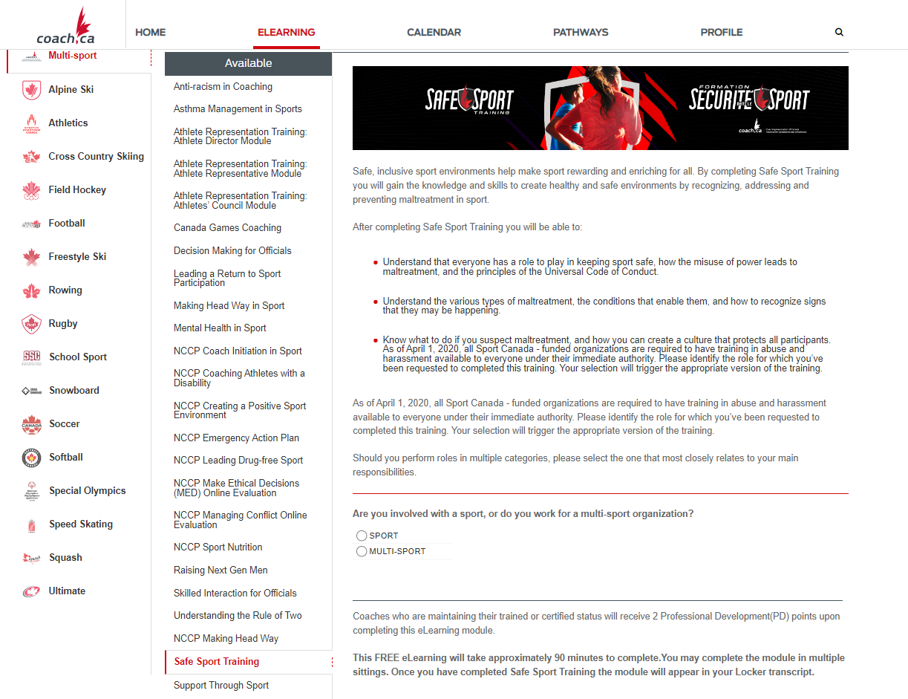
6. Select options that define you;
- Are you involved with a sport, or do you work for a multi-sport organisation?
- Select School Sport Canada.
- Select all involvement types that define your role.
7. Click the “Continue” button to go to the next page and click “begin” to complete the course (red button highlighted in yellow).
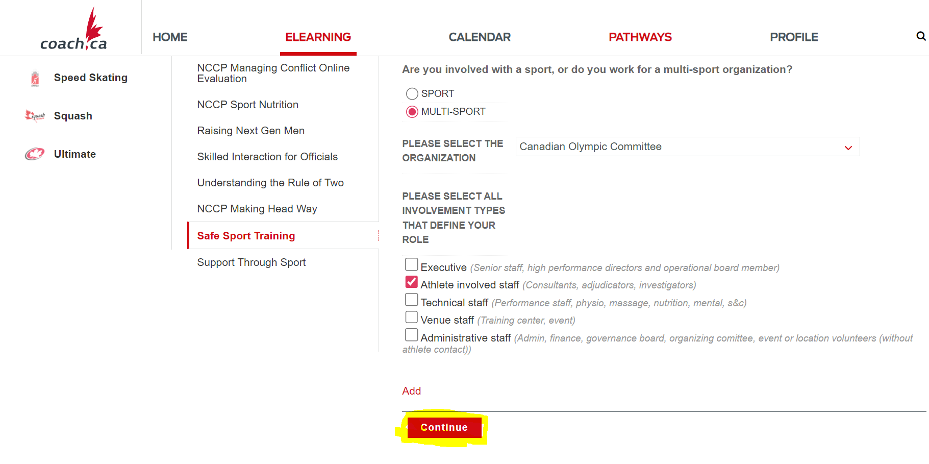
8. Be sure to provide your Athletic Director with your NCCP number.

Coaching School Sport: Redefining Winning–Access Guide for ASAA Members
Here are the steps to access Coaching School Sport: Redefining Winning:
1. Go to coach.ca
This will take you to the CAC page.
2. Click “The Locker” at the top right of the page
This will take you to the Login page (the red button highlighted in yellow below).
3. You will need to sign in using your NCCP number
a. If you do NOT have an NCCP number, you can create one by clicking “Don’t have an NCCP #? Create one now!”. Complete the online form.
b. If you do not know whether or not you have an NCCP number, there are a variety of online tools available to assist you including:
i. Look up my NCCP #
An email will be sent to your existing account confirming your login information.
ii. I don’t remember my email
You will be asked to provide your name and birth date. If you have an account, an e-mail will be sent to the registered address.
c. If you think you have an NCCP # and the online tools did not help you find it, you can contact the CAC for support by emailing coach@coach.ca.
4. Once you are signed in, click “E-learning” on the navigation bar. This will direct you to the e-learning page where the default setting is “Multi-Sport”.
Note: You can adjust this option using the drop-down menu to select other sport/partner options. When the ASAA LMS transition is completed, there will be a “School Sport Canada” option and this is where all of the School Coach courses will be housed.
5. Ensure that “School Sport” is listed on the drop-down menu. On the left sub-menu, select “Coaching School Sport: Redefining Winning” under the list of available courses. 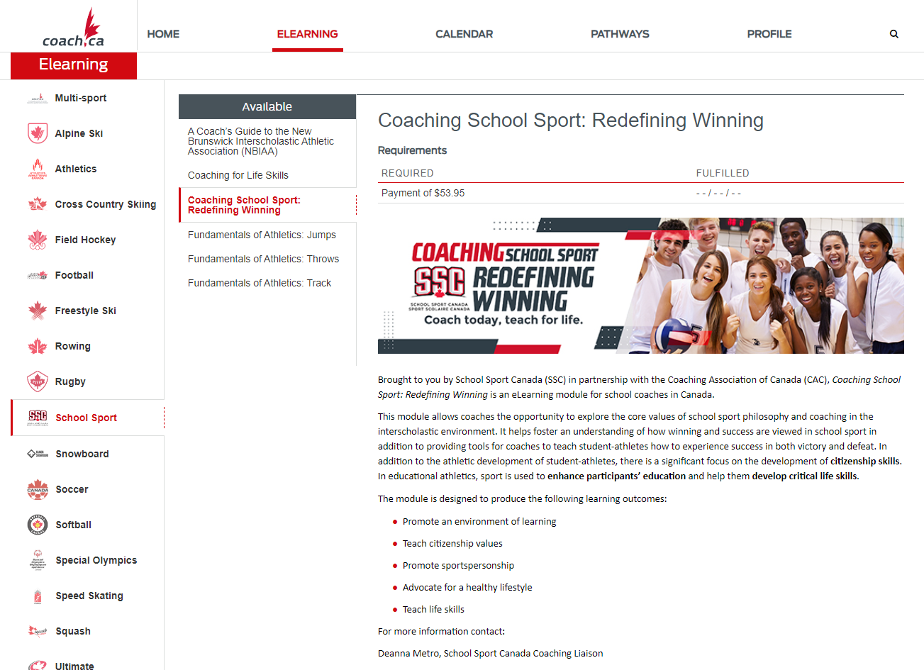
6. Click the “Pay Now” button at the bottom of the page (scroll down). Please Note: There is NO discount code for the “Coaching School Sport: Redefining Winning” course. The ASAA is not responsible to reimburse the costs associated with the course.
7. Be sure to provide your Athletic Director with your NCCP number.

Athletic Directors
Here are the steps if you are wanting to check which courses your coaches have completed (to view the Coach Transcript):
1. Go to coach.ca
This will take you to the CAC page.

2. Click on the “Coach Transcript” feature at the top right corner of the main page.
(the button highlighted in yellow below)
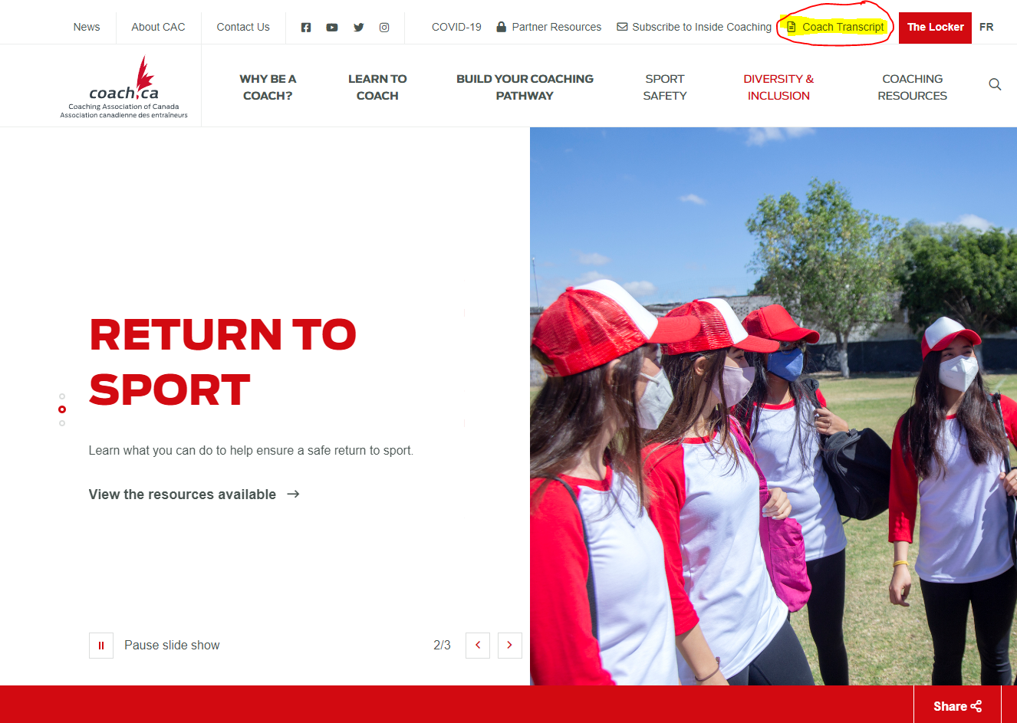

3. On this page you will need the NCCP number of the coach to input, and the coach's last name.
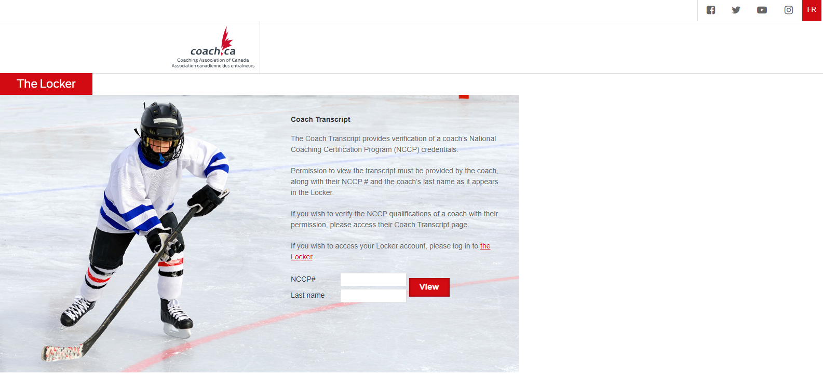
4. After entering the information you will then see this window (with the addition of the coach’s name) The page defaults to show the coaches transcript but it can be reselected if you click off.
